OpenExam Online –   
Teachers Manual

An getting started guide for the OpenExam web interface targeted at teachers/employees.

Version 1.1 (2016-05-25)

Table of Contents

Welcome to OpenExam 3

Before the exam, quick introduction 4

Creator 5

Contributor 5

Invigilator 5

Corrector 5

Decoder 6

How to start a new exam 7

*Breif description of general functions* 7

*Create a new exam* 8

Delegating Roles 11

Managing students 12

Methods for adding students 12

Anonymous code 12

Add single student or a list of students 13

Import from spreadsheet or text file 13

Import a group or course 14

Select what to import 14

Manage existing students 15

Adding questions 16

Write question 16

Answer option 19

Points 21

Adding supplementary materials 22

Edit or Delete questions 25

Checking and Publishing the exam 26

Student View – preview your exam 27

Editing exam details after publishing 30

Access Control 31

*Enable or disable* 32

*Pre-defined locations* 32

Wildcard locations 34

*Custom locations* 34

During the exam 36

Adding/removing students during the exam 36

Changing the exam time during the exam 38

After the exam 39

Being a Contributor – adding questions 40

Being the Corrector – correcting an exam 42

Being the Decoder – decoding an exam 45

Student results 47

*Example* 47

# Welcome to OpenExam

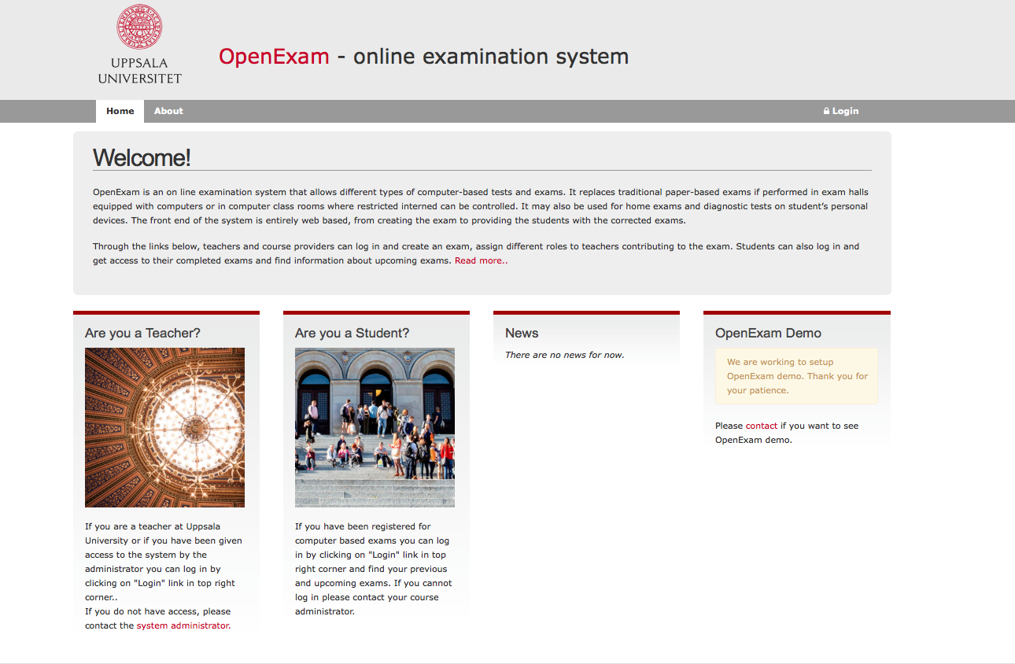

OpenExam is an service platform for conducting computer based exams. This manual describes the web interface for the the second generation of OpenExam.

For more information, please visit [http://openexam.bmc.uu.se](http://openexam.bmc.uu.se/)

openexam.bmc.uu.se

# Before the exam, quick introduction

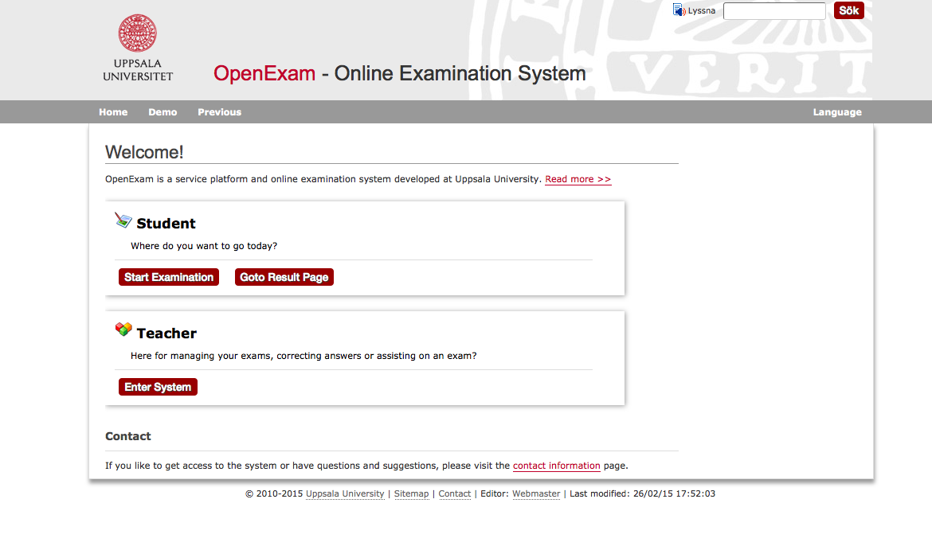

Under “Teacher” click “Enter System”.

This takes you to the home page and from here you log in to start using the system.



When you have logged in, choose the My Exams tab.

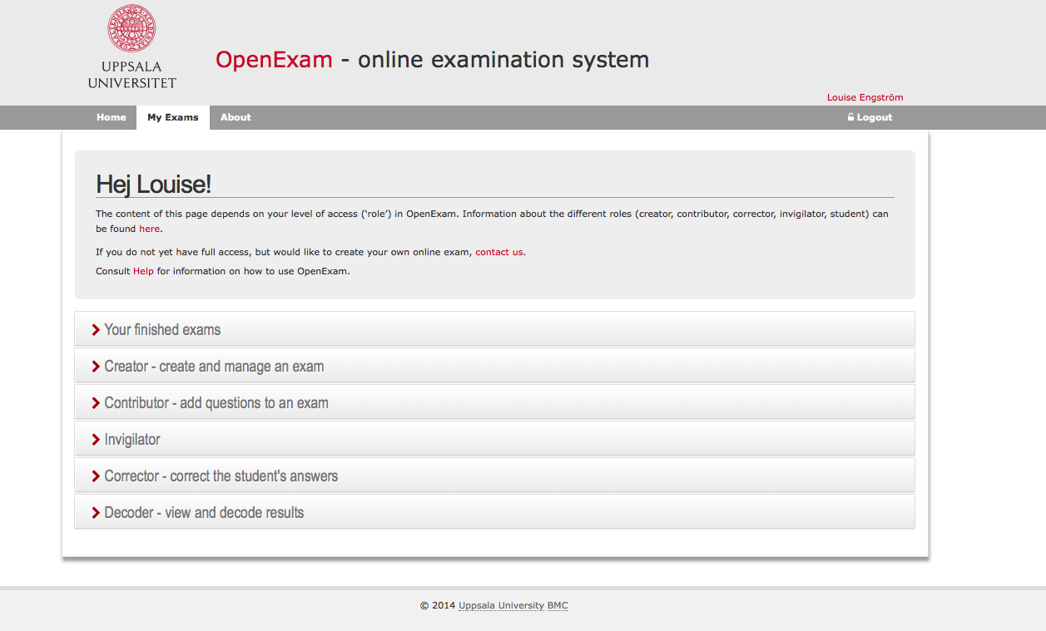

The exam archive lists all exams on which you have permission to perform various task. One such task could be to correct answers or contribute questions.

All tasks is bound with a specific role on an particular exam or question, either implicit granted or explicit delegated by the exam owner.

## Creator

The creator is the person that has created the exam, thus becoming its owner and manager. The creator can defines properties (like grades) and delegate roles (for different tasks) to co-workers.

## Contributor

A contributor is usually a teacher at the course that can add questions to the exam. The contributor will automatically become the corrector of his/her contributed questions.

## Invigilator

The invigilator can add or remove students, change the time settings for all or single students and modify/accept locations from where the exam can be accessed.

## Corrector

Although the contributor automatically becomes the corrector of “own” questions, it is also possible to assign multiple or different correctors for a question. The corrector role is connected with an specific question, not the exam as a whole.

## Decoder

When all questions have been corrected, the exam is decoded and the students’ identity is disclosed. After this point, the exam is frozen from further correction and the results can be reported.

# How to start a new exam

When you are logged in the “My Exam” window will be displayed. Click on (open) the “Creator” view.



This will show all your exams. To allow easy sorting it is important to use a logic labelling.

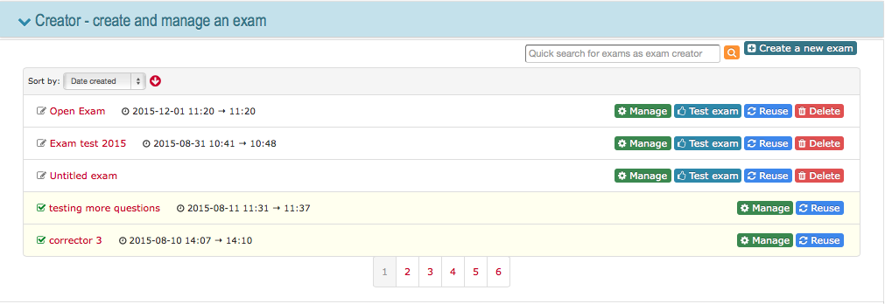

## *Breif description of general functions*

**Manage:**

The manage function allows you to do any necessary changes to the exam and basically it will take you directly to the view of your already created exam where you can add questions, include settings and assign roles etc.

**Test exam:**

This function allows you inspect the students’ view of the exam for any errors.

**Reuse:**

A pop-up window allows you to select what you wish to reuse (the questions only, or together with the same correctors, or all exam roles). You can reuse both unused and previously finished exams

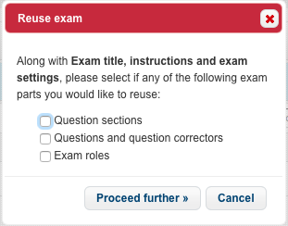

**View:**

Finished exams may not be modified but you you can still view questions and settings- and also reuse different parts as described above.

## *Create a new exam*

Click on the “Create a new exam” button.



A pop-up windows will appear from where core exam information can be entered. Required fields are marked with (*) and has to be completed for an real exam.

Remember to write any exam specific information to the students in the box provided. Also bear in mind that the grades are given as percentage of the total score.

You can always return to this window and add/change text by clicking on the ratchet symbol.

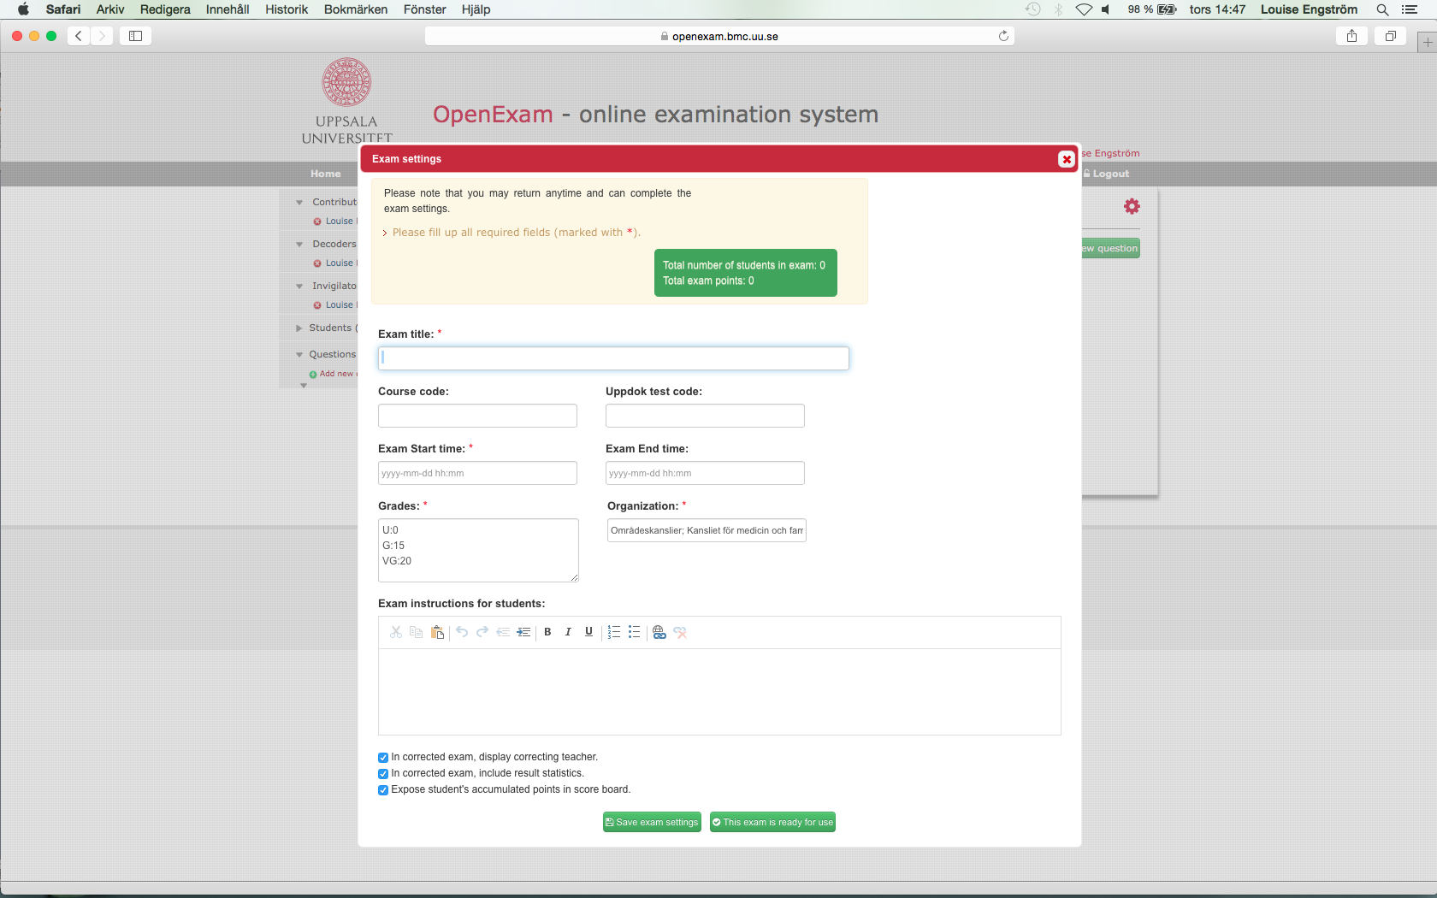

Drop-down box allows you to chose the date and time for the exam. You can also add this manually directly into the field provided.

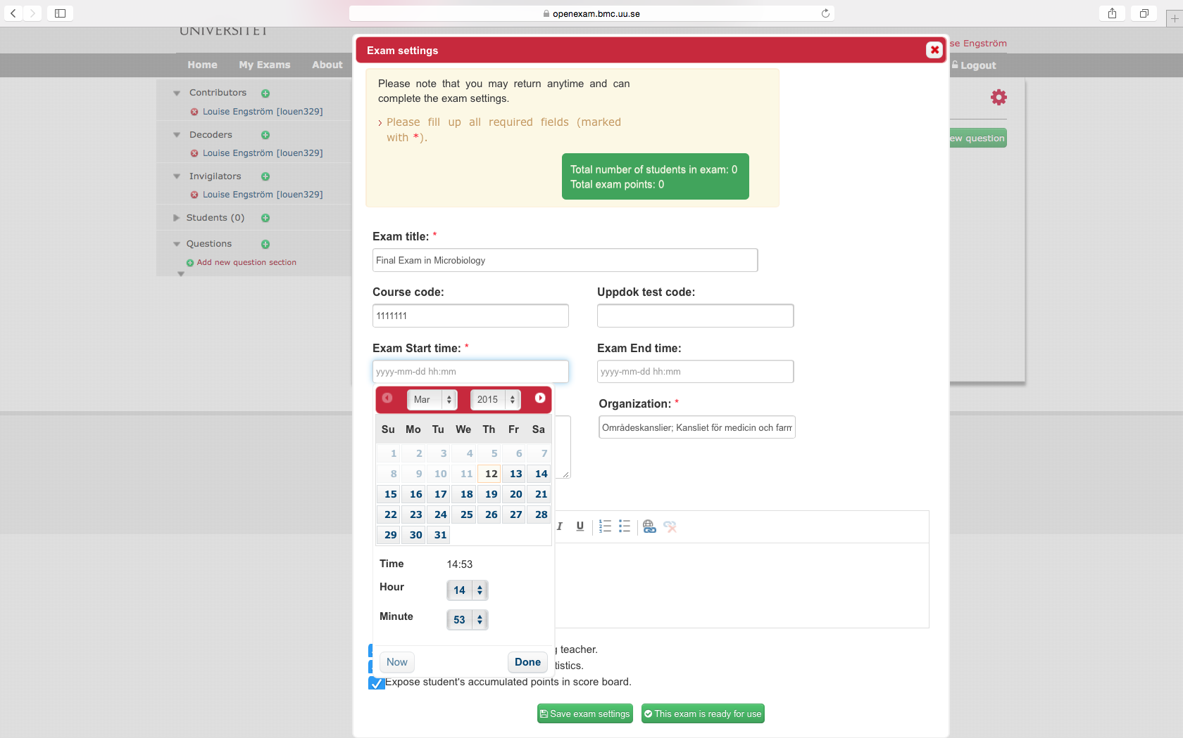

Save the settings by pressing the “Save the exam” (1) button and close the pop-up window by clicking the top corner cross (2).

The button “Publish this exam” (3) should **not** be used until the exam is ready to be used.

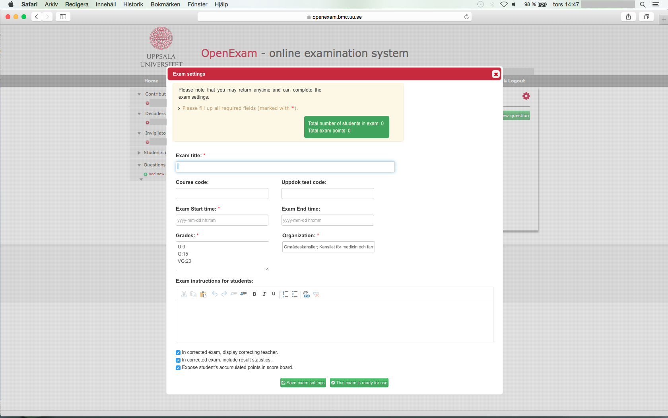

1

2

3

After closing the settings window you can start delegating roles, adding students and adding questions. By design, you should have been granted some roles yourself giving you permission to perform various tasks.

## Delegating Roles

The system supports both centralized and collaborated/distributed work on an exam. By delegating roles to co-workers, you can grant other people permissions to perform distinct task, inviting them to participate in a collaborated work on an exam.

In the left pane the different roles are listed (see page 4 for description): Contributors, Invigilators and Decoders. By default, when creating an exam you will automatically be given these roles.

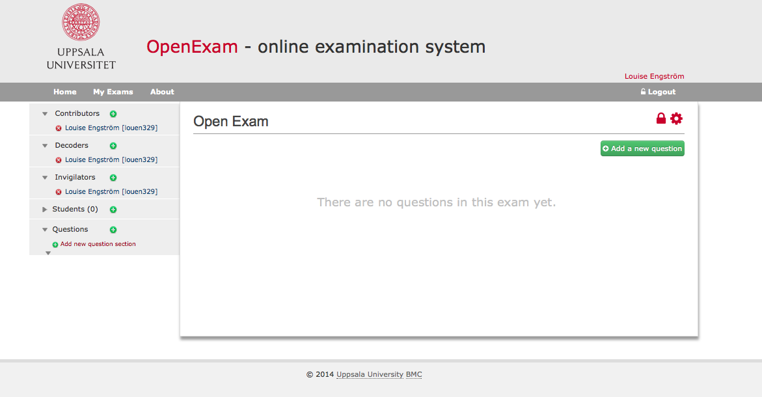

To assign a role to someone else, for example a contributor you click on the **green** plus next to the title:

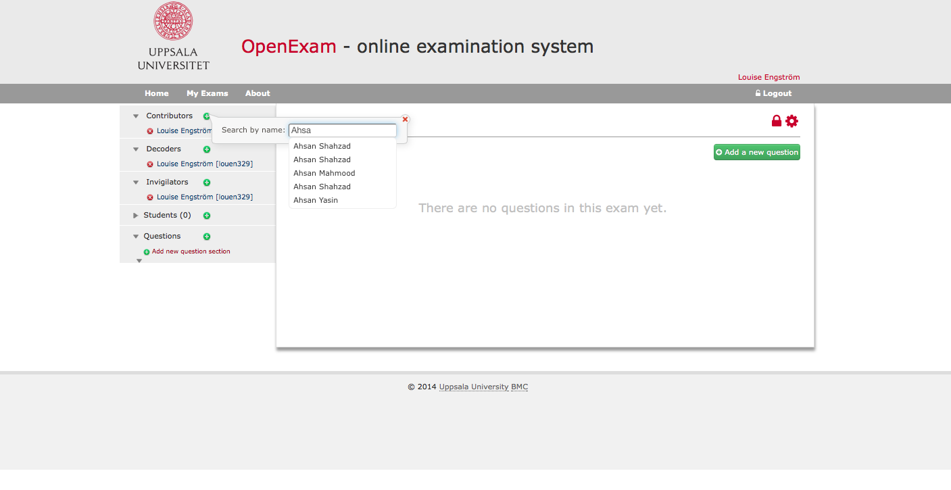

In the textbox that appears you can search for people by their full name or insert their username.

With the same procedure you select persons for all other roles. Remove names using the red cross. You can also remove yourself from a function (e.g. as a decoder).

The system can handle multiple user domains for authentication and directory services for searching. For more information about this, please send an email to [openexam@bmc.uu.se](mailto:openexam@bmc.uu.se)

## Managing students

Only students added on an exam can access it and its the invigilator that manage students on the exam. From within the exam management view, the creator can manage students too, using his/her implicit granted invigilator role.

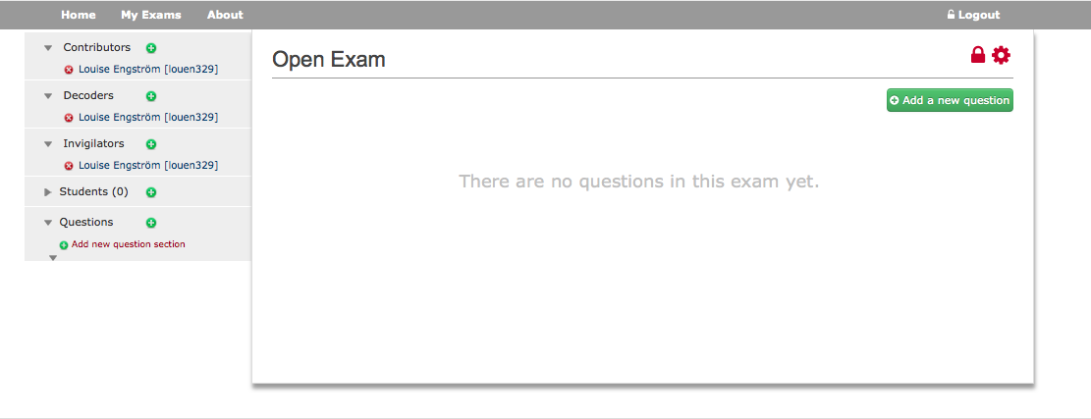

Click on the **green** plus next to the “Students” label. A pop-up windows will appear from within students can be added or removed.

### Methods for adding students

Either single students or multiple at once can be added. Three methods are provided:

* Add students by list (copy and paste)
* By importing a spreadsheet or text file.
* By importing a group or course.

### Anonymous code

The anonymous code can be used when reporting results and is also shown for correctors. All methods supports an anonymous code to be supplied.

If an anonymous code is not provided during student registration, then the system will generate one for you.

**Caution:**

The anonymous code has to be unique within the exam, but can be reused on other exams. The system will try to enforce this uniqueness, but for technical reasons this is not always possible.

### Add single student or a list of students

The first method is the simplest. Just write or copy & paste one or more students on each single row.

The first field should be an identity (a personal number or username). An optional anonymous code can be supplied. The identity and the optional anonymous code (if any) should be separated by a blank space or tab character.

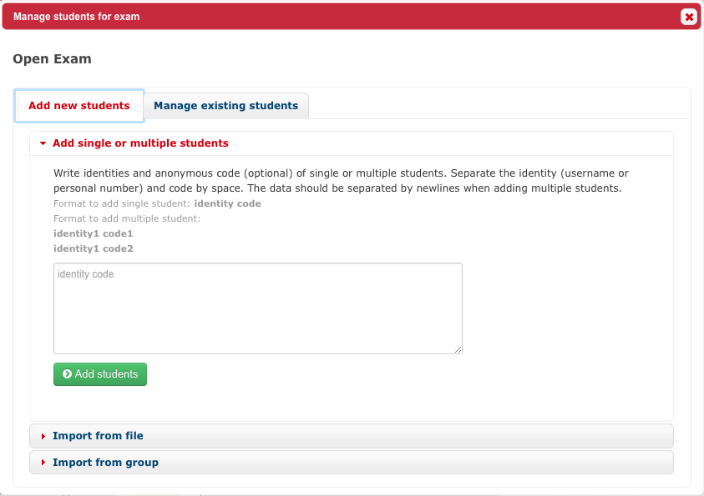

### Import from spreadsheet or text file

The second alternative is to import a list of students from a file. The most commonly used spreadsheet file formats are supported, as well as, comma separated text values or tab separated.

If import of an spreadsheet file fails (perhaps because the content was copied from a web page), please try the following:

* Swap/move column containing personal numbers to first column.
* Remove columns/cells containing images/pictures.

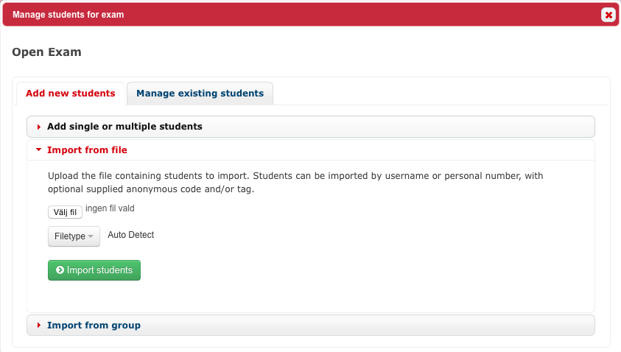

### Import a group or course

The third option is to import students being group members or registered on a course (for example an UPPDOK course code or an active directory group in the USER-domain).

When importing an group from active directory, use the display name. For example “UPPDOK – 3PA014”. Use “3PA014” for importing the same students list, but from UPPDOK.

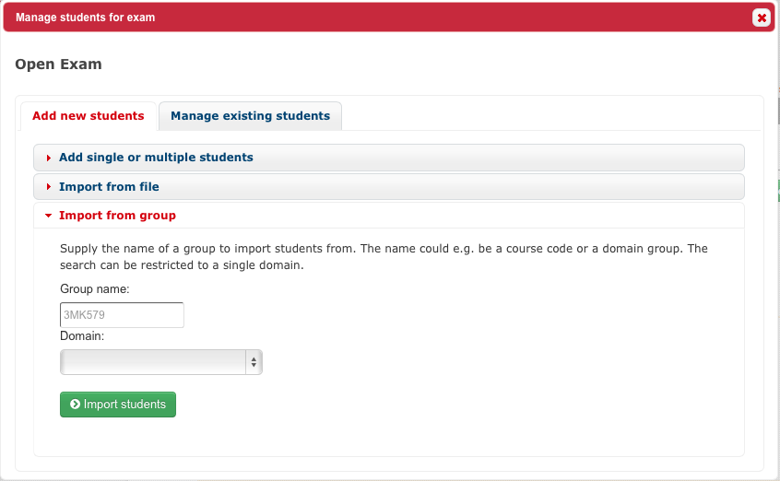

### Select what to import

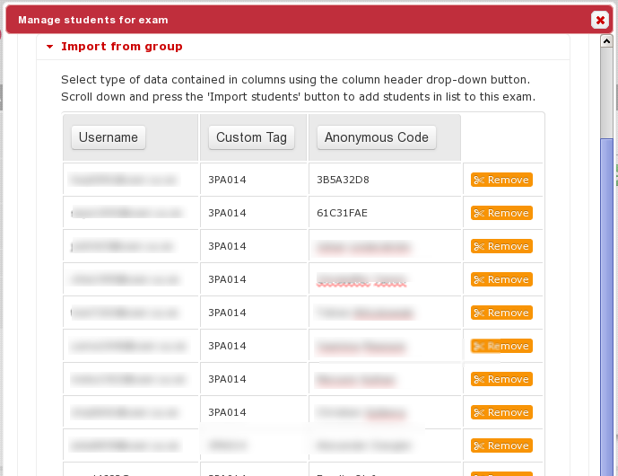When importing from file, group or course it might be required to select how columns in input data should be mapped to student properties like usename, personal number, custom tagging and anonymous code.

The view shown after submitting e.g. an course code or file allow you to define this mapping. Start by removing unwanted data (i.e. table headers), then continue by selecting the column containing username.

The view can be used for editing data before import. Once satisfied with the list, scroll down and press “Import Students” to actually perform the import.

Any unmapped columns will be ignored in the final import step.

### Manage existing students

The “Manage existing students” tab can be used to remove students one by one. Click on the little garbage bin next to his/her name to remove that student.

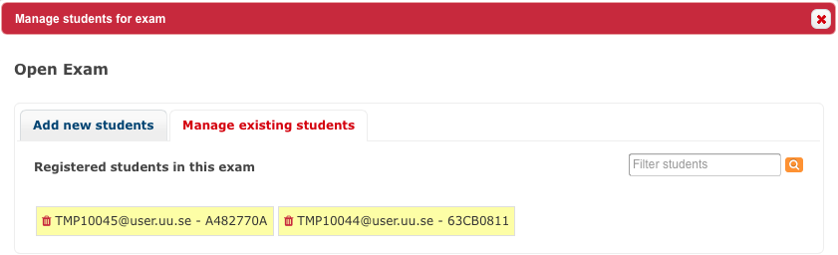

Close the popup window by using the red cross in the top right corner.

## Adding questions

Adding questions to an exam can be performed by anyone having the contributor role. Within the selected exam click “Add a new question”



Three sections must be completed when adding a question: “Write question”, “Answer option” and “Points”.

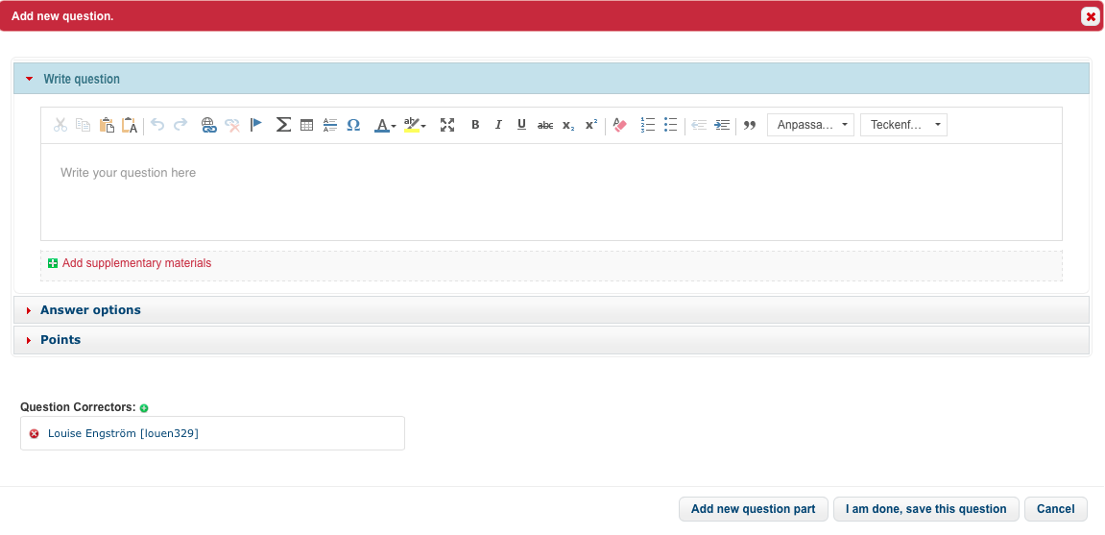

### Write question

Type the question in the window provided (1). The layout may be modified using the top bar (2). You can also add supplementary material (3), for example a text document, pictures, movies, tools or websites related to the question.

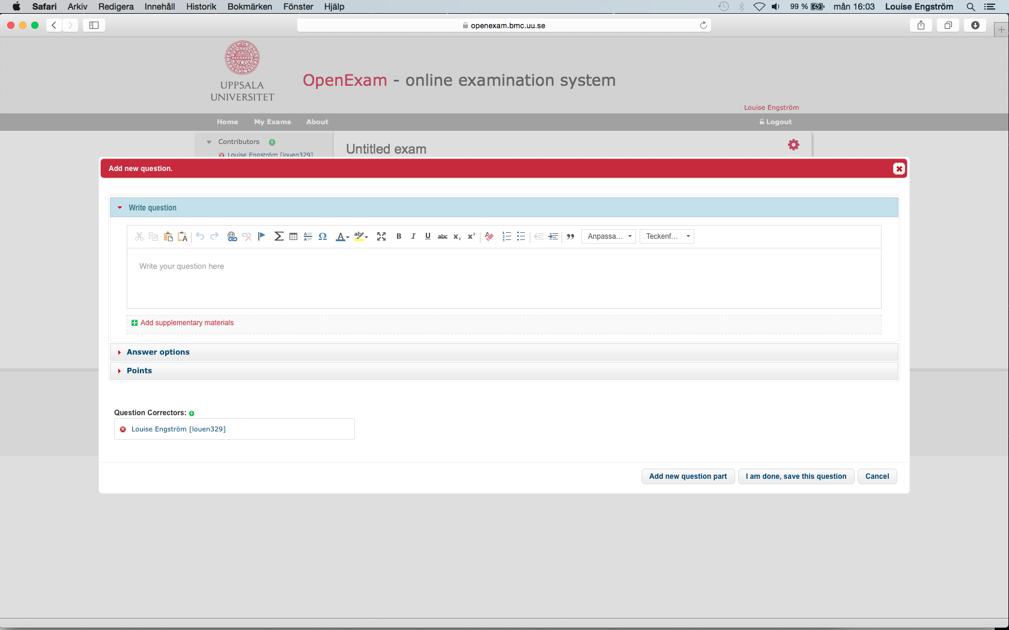

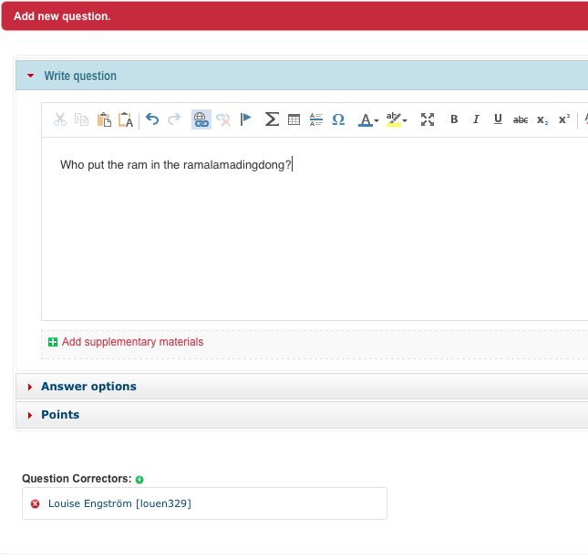

1

2

3

**Note:**

If you (as the exam creator) have added questions, you cannot choose a different corrector unless he/she has been assigned the role “contributor”. This is a known bug in the web interface that will be fixed.

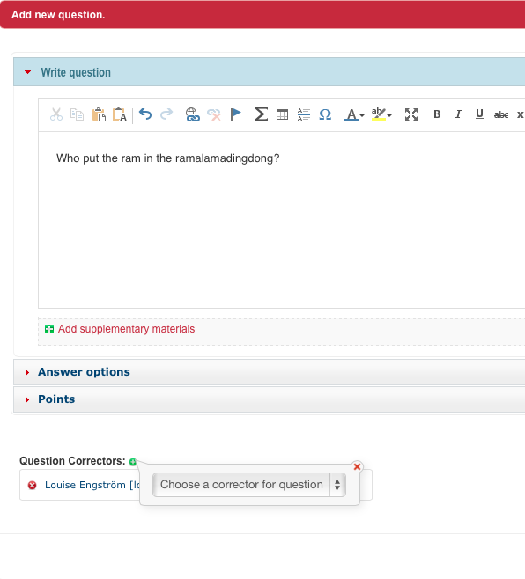

### Answer option

Next, you chose which type of answer you want.

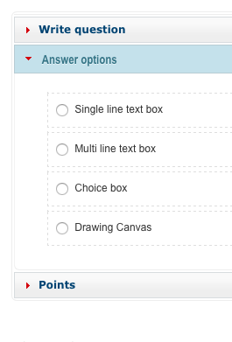

A “Single line text box” is intended for short answers. Typical used for questions requiring limited space for the answer, like “What's the meaning of everything?” [23].

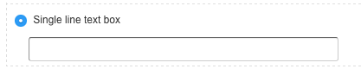

The “Multiple line text box” can be used for longer answers and also allows the student to use formatting of the text. Word or character counting is planned to be added, but currently missing.

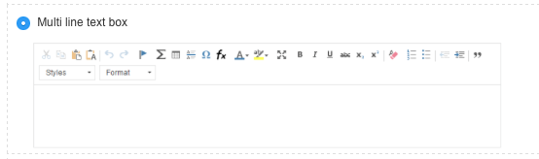

The “Choice box” is for multiple-choice questions.

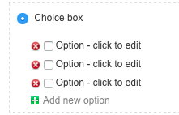

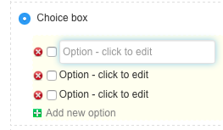

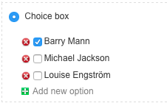

Add the alternative answers and mark the correct answer(s) by ticking the box. Multiple choice questions are automatically corrected.

Algorithm:

The algorithm for calculating the score on single/multiple choice questions are +1 for correct selected alternative. -1 for wrongly selected alternative.

The +1/-1 is summed and divided by number of correct alternatives. That number is then multiplied by the maximum score on this part of the question. Negative scores gets adjusted to zero.

“Drawing canvas” will give the student a canvas on which they can make basic drawings.

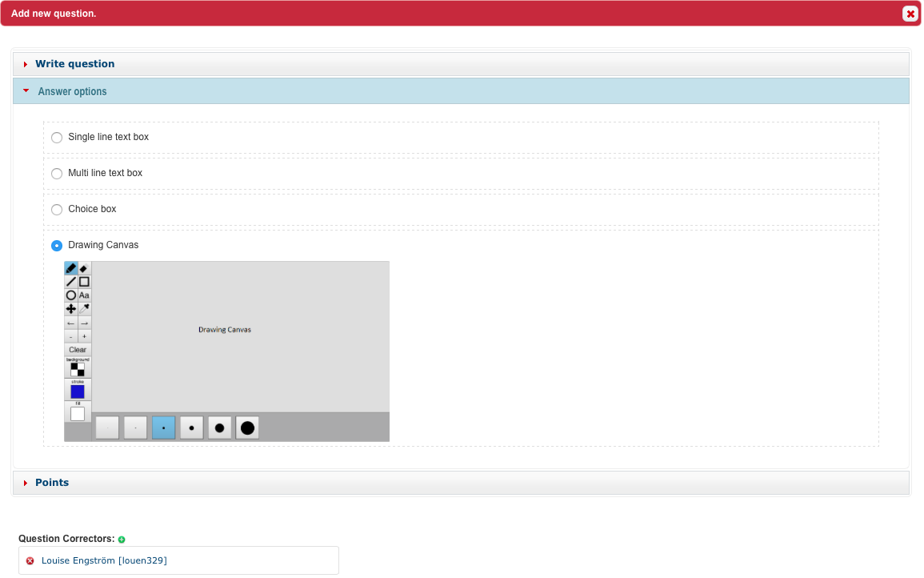

### Points

Finally, you write how many points the correct answer gives. Then save your question.

If your question has two or more parts you add a part by clicking “Add new question part” next to “I am done, save this question”, see below picture.

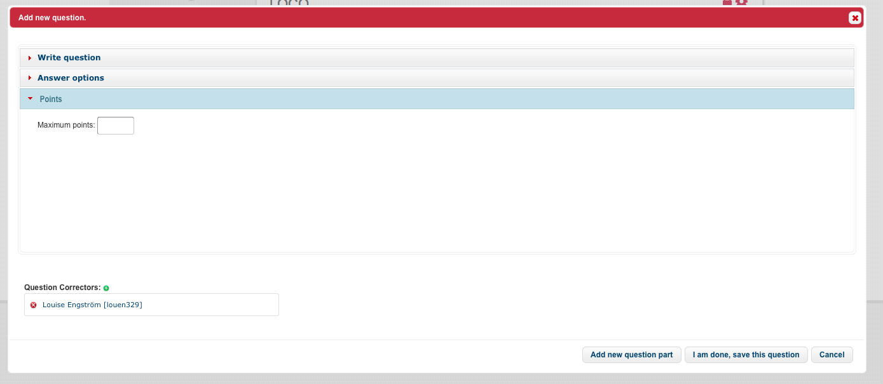

This will display a window, called part “b”, where you can add the next section of your question.

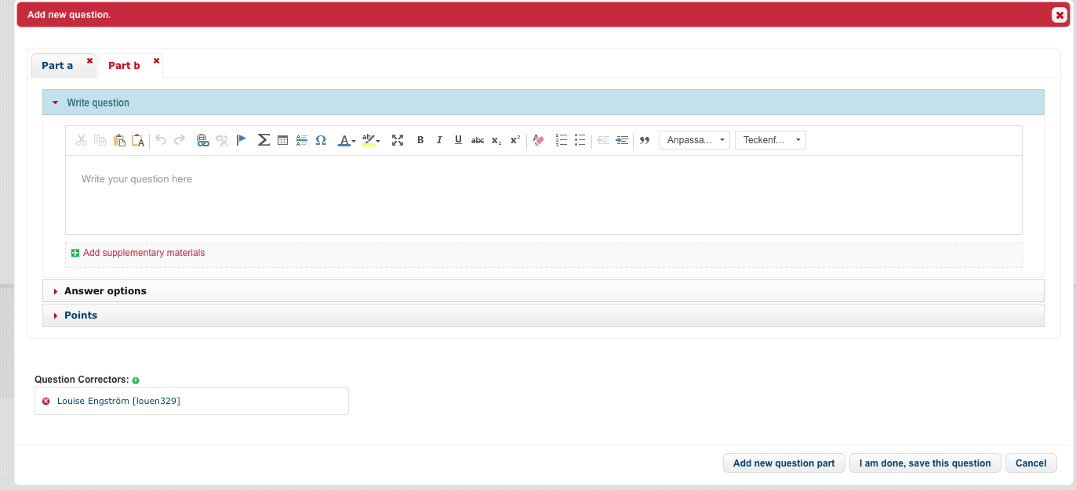

When you are done, save the question.

### Adding supplementary materials

Supplementary material may be in different formats, PDF, a video-clip, an excel sheet etc.

Click on “Add supplementary materials” 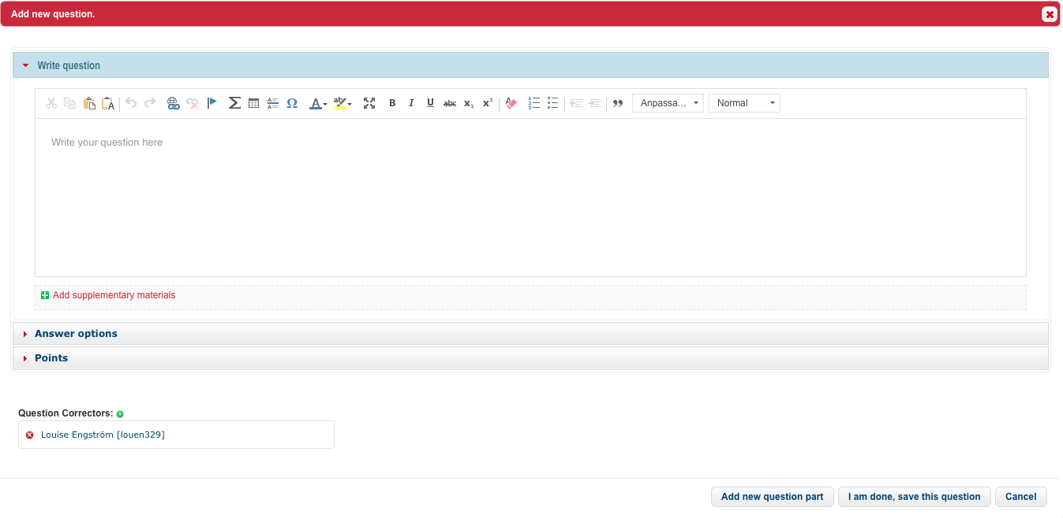

Any previous uploaded files will be shown in the left pane (your library of files). These may be directly selected and used as supplementary files to the question.

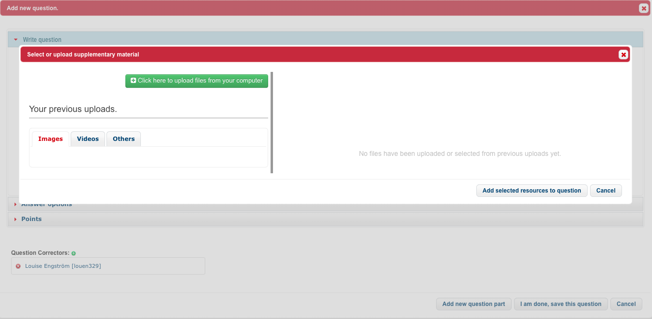

Alternatively you can upload a new file by clicking on “Click here to upload files from your computer”. The uploaded file will now enter your library of files and also shown to the right as the selected file.

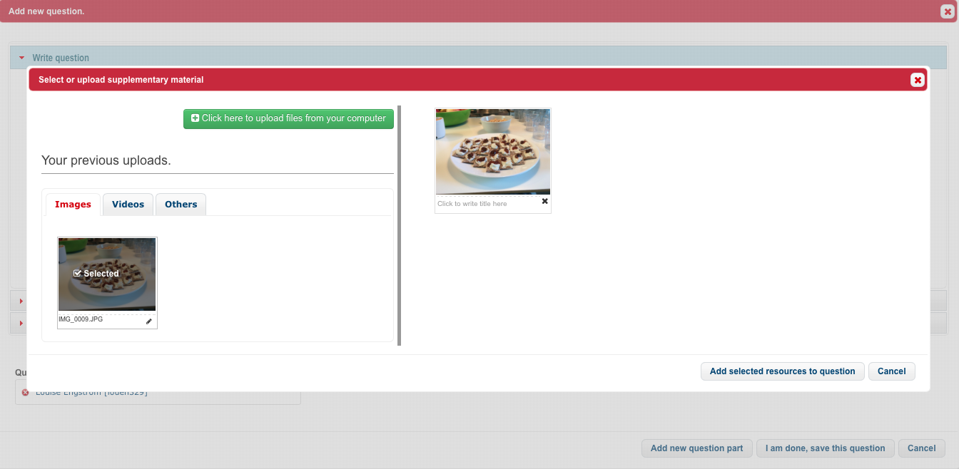

Click “Add selected resources to question”.

In the question window you can see that your file has been added to the question

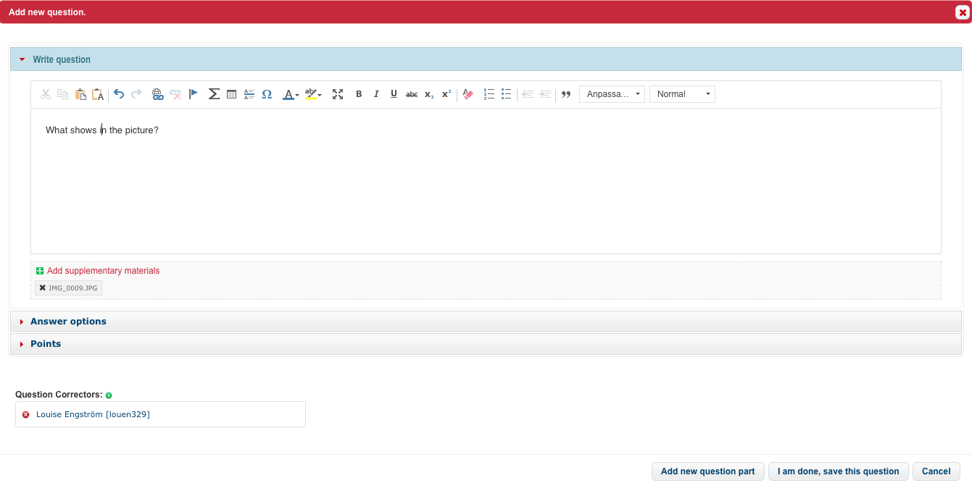

### Edit or Delete questions

When you have completed all your questions editing is possible through different functions: To delete, use the red cross. To edit, click on the pen and you will return to the question window.

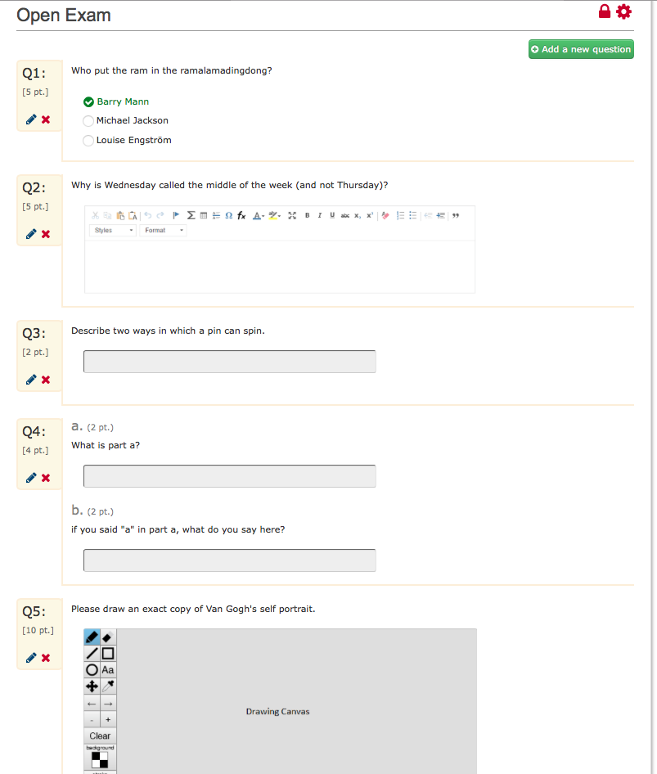

## Checking and Publishing the exam

When you are satisfied with the questions you could check how the exam will appear for a student view before publishing it.

To do so you click the “Preview Student view” button at the bottom of the page. Note that you may also access this view from the function “Test exam” in the “My Exam” view.

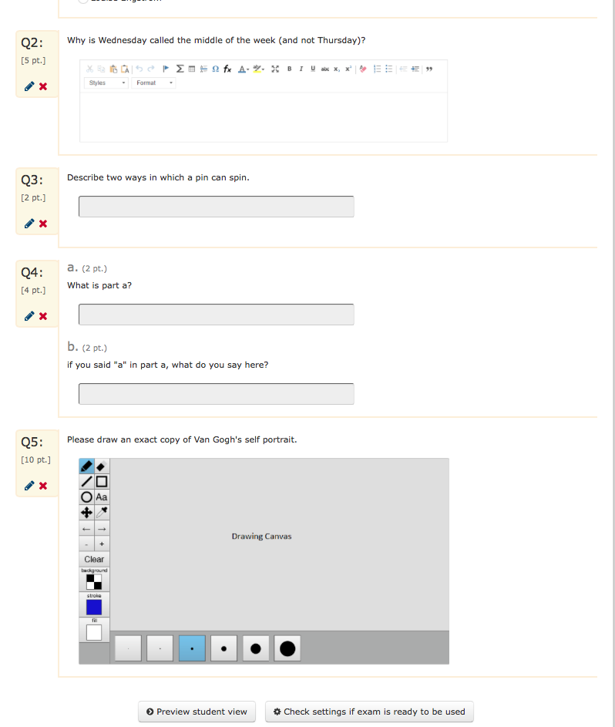

### Student View – preview your exam

The following page appears.

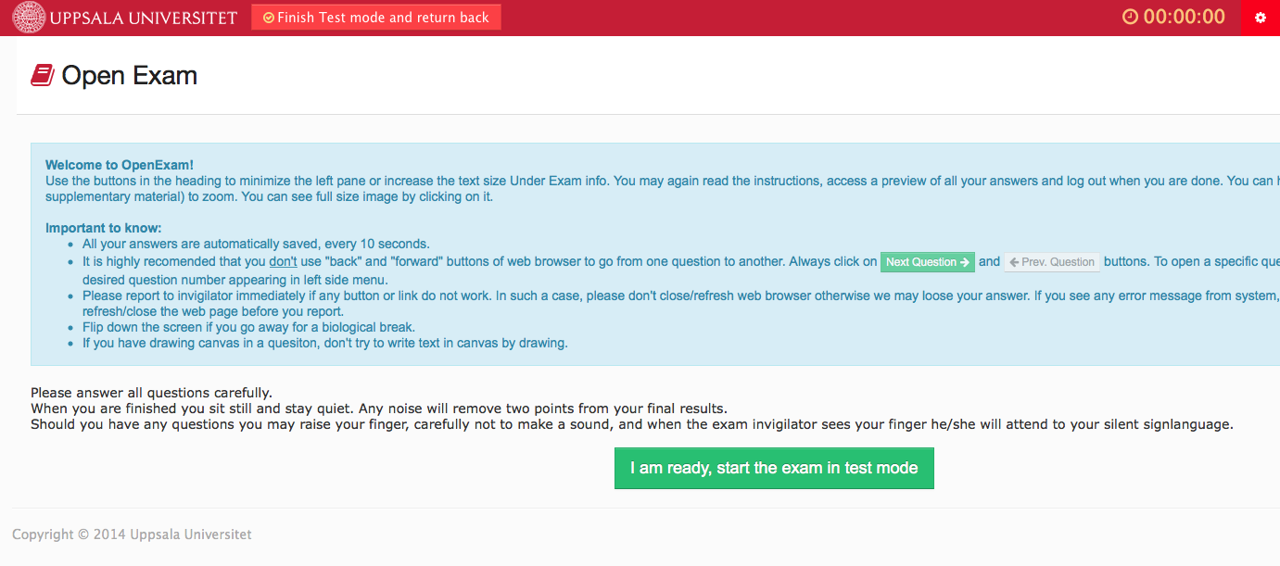

When you click “I am ready, start the exam in test mode” you will see each question the way it will be seen by the student.

Note that you will not be able to answer any questions in this view.

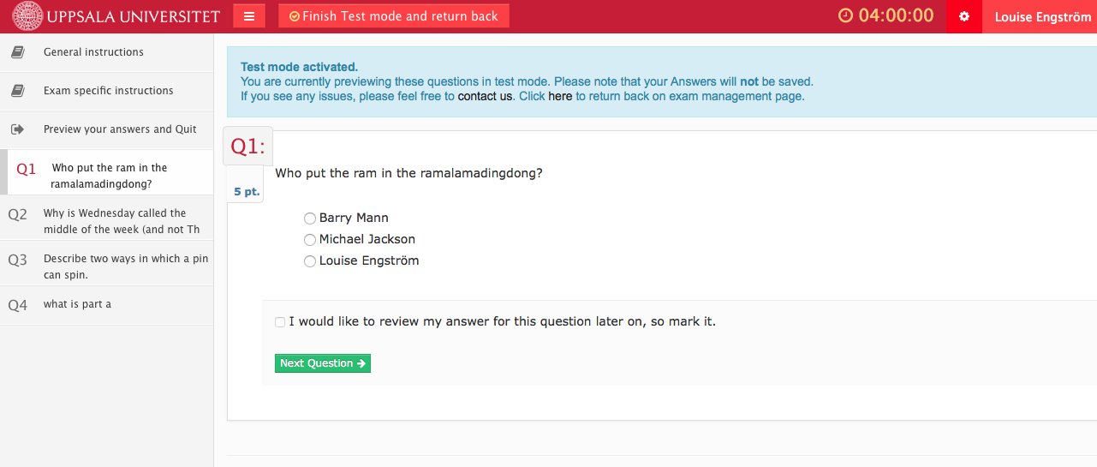

The left pane shows all questions (or part of them)

This pane also includes

“General Instructions” to the students on how to navigate and perform the exam.

“Exam Specific Instructions” contains the specific information you have included (see page 7)

“Preview your answers and quit” allows the student can preview all his/her answers before submitting the exam.

When you have finished checking your exam, click on the “Finish Test mode and return back” button in the top banner.

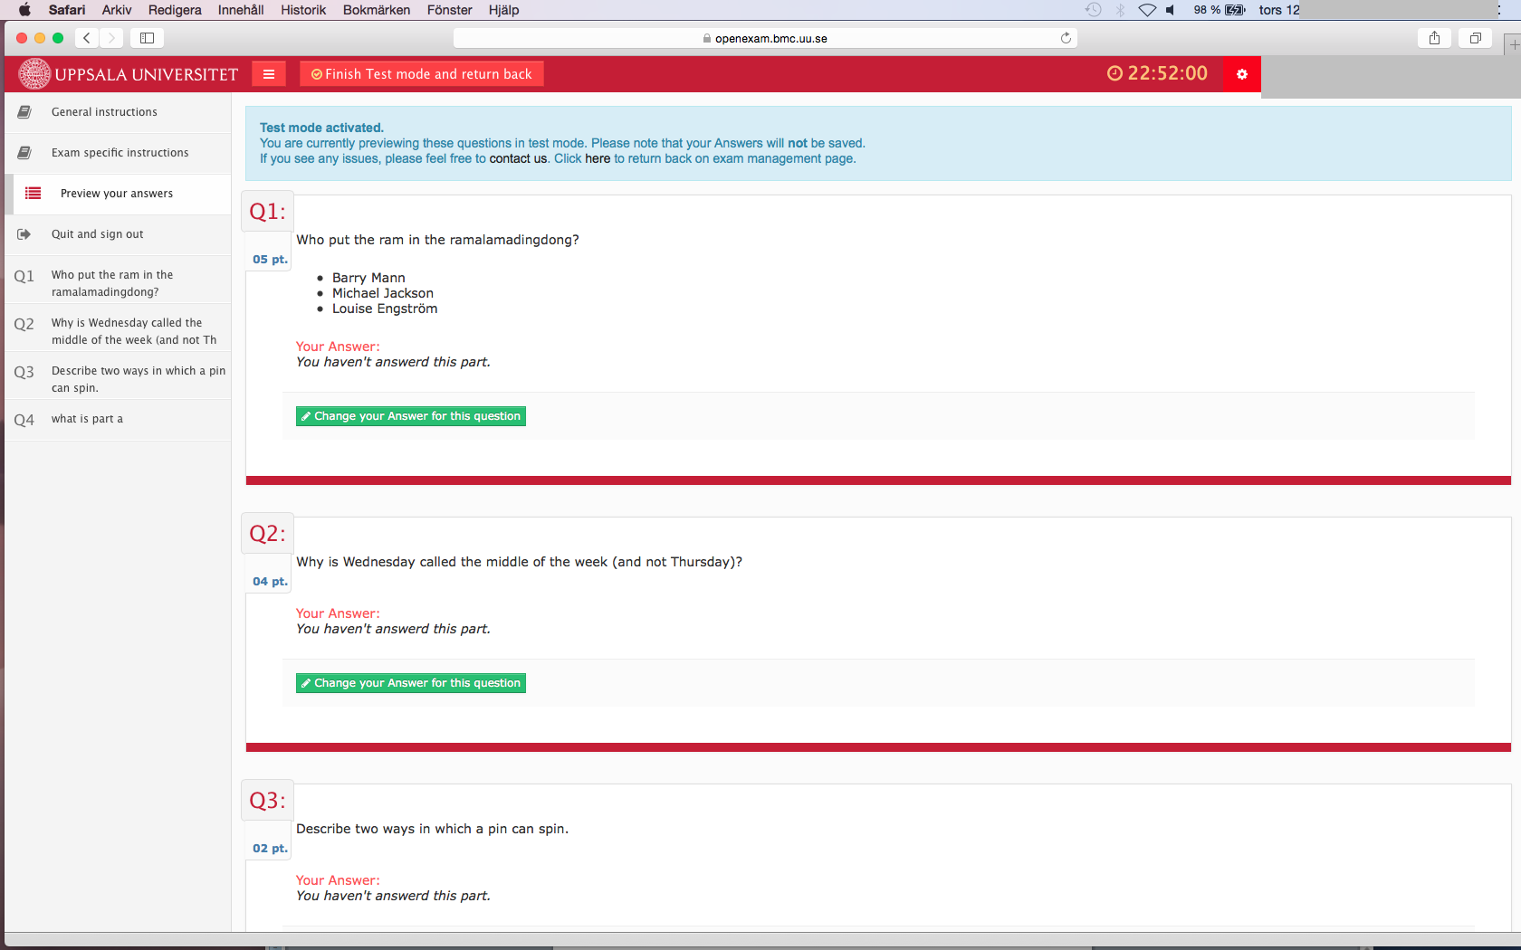

This will take you back to the start page.

To publish your exam, go to “Creator – create and manage an exam”.

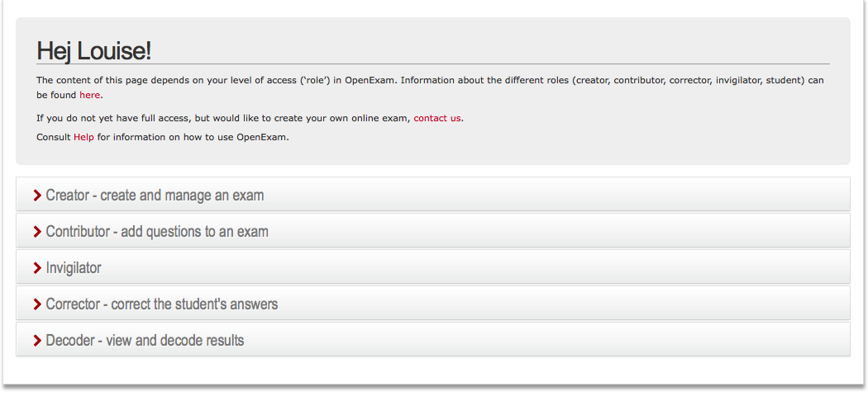

Choose “Manage” next to the exam you wish to publish.

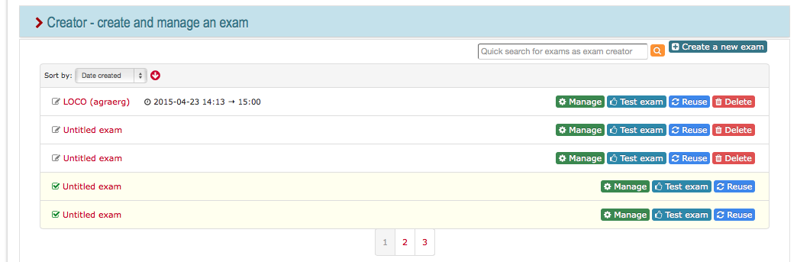

Click “Check settings if exam is ready to be used”.

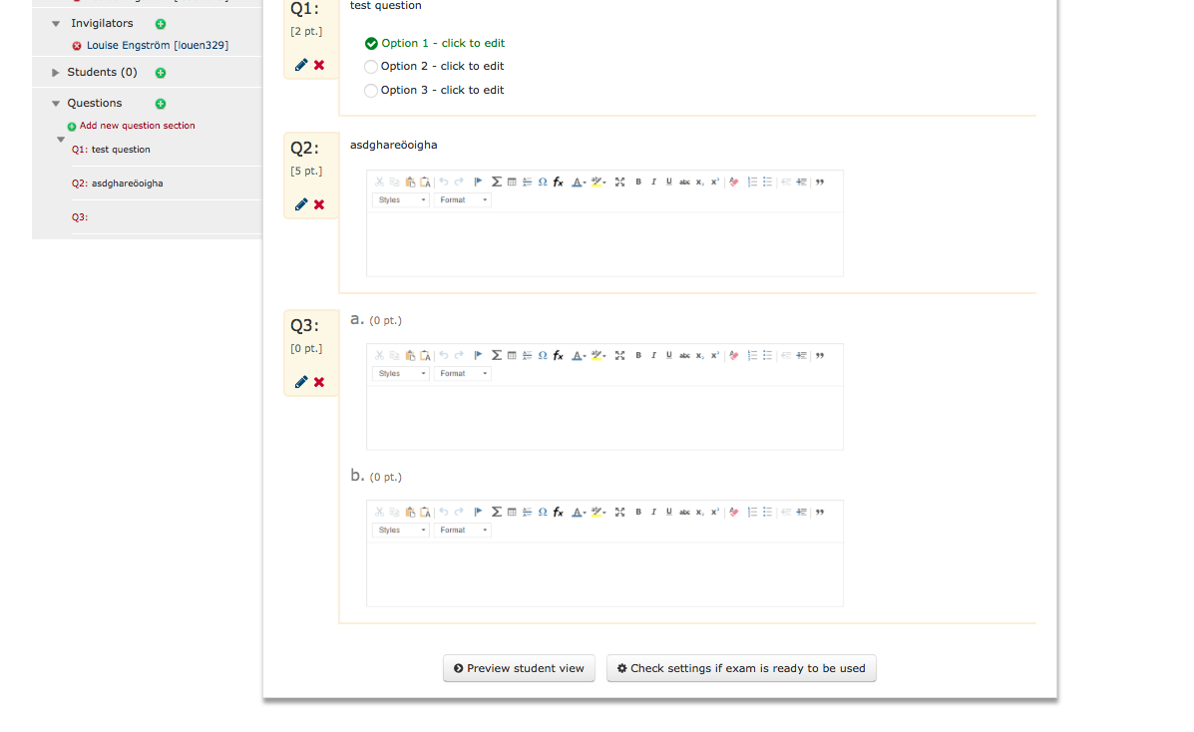

You may perform a final check of all details before you publish: the name, course code, date and time, grades and exam information.

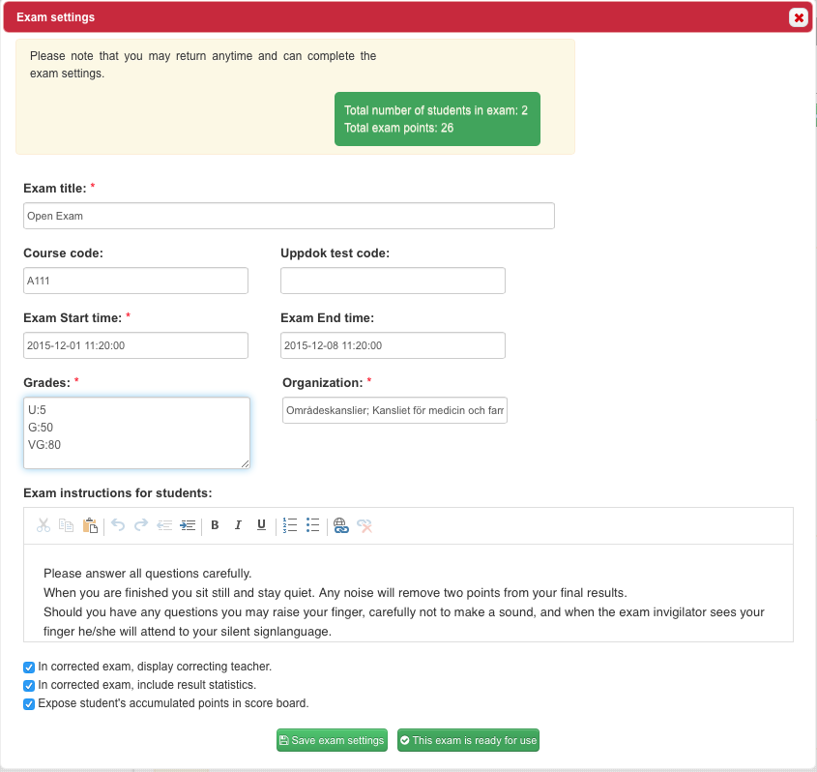

Click “This Exam is ready for use”. Now the exam is active and will automatically start on the date and time you have provided.

When an exam is published you will see the green banner in the top corner. This also means that all students you have entered can see the exam as upcoming.

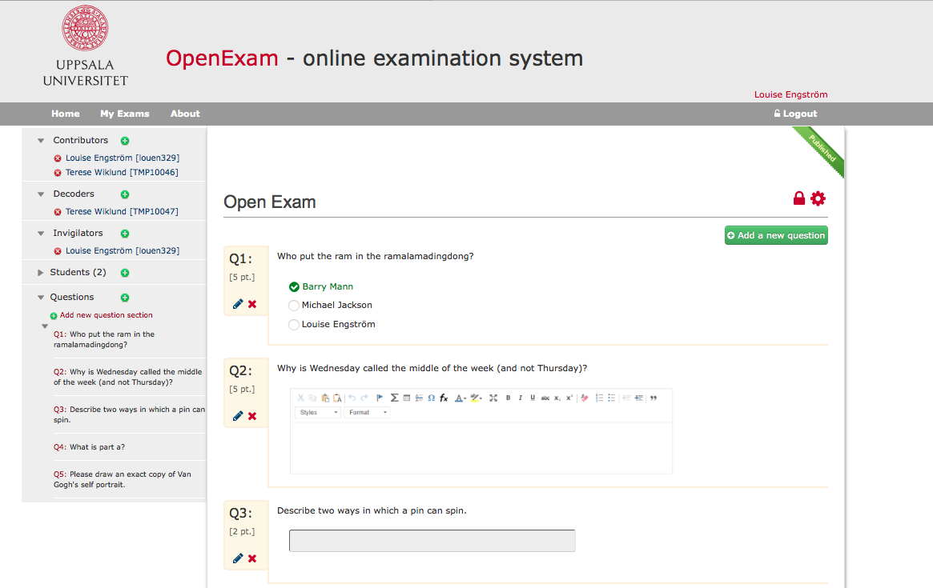

## Editing exam details after publishing

If the date or time of the exam should be change after you have published the exam you can change it by clicking on the cobbed wheel.

1. Log in.
2. Click on “My exams”.
3. Under “Creator”, choose the exam you are going to update.
4. Click on the cobbed wheel in the top right corner.
5. Update exam details.

Note:

You can only change the time and date of an exam **before** the original start date.

Questions **cannot** be modified when the exam has been published.





# Access Control

The places from where the students can conduct an exam may vary, as well as the level of access control required. It's up to the exam creator to decide how strict access restriction that is needed for an exam.

## *Enable or disable*

To enable/disable access control:

1. Go to “My Exams”
2. Click on the “Manage” button next to the exam you want to edit.

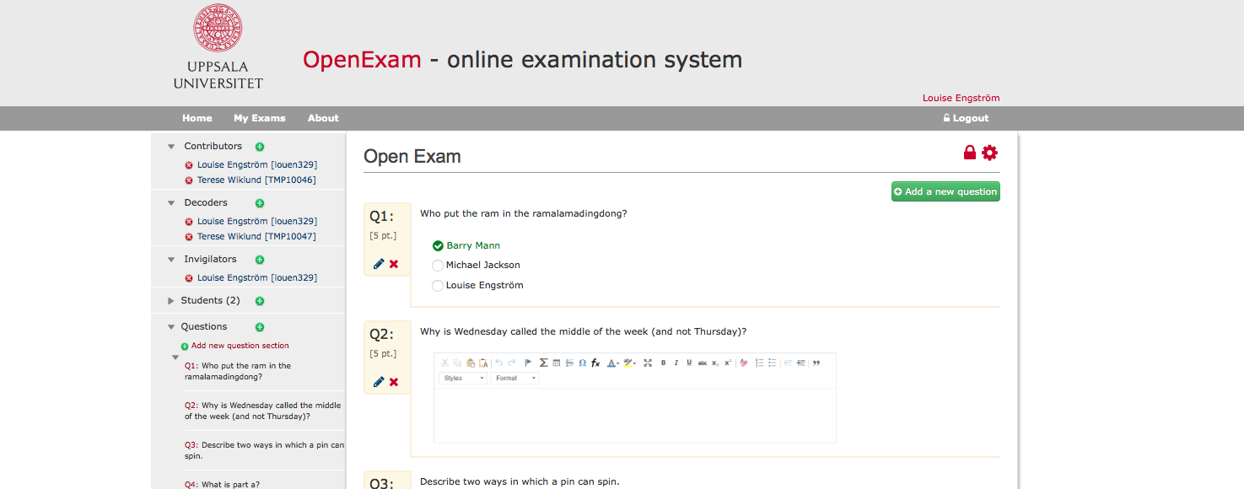

Click on the padlock icon. The dialogue window allows you to define from where the exam can be accessed.

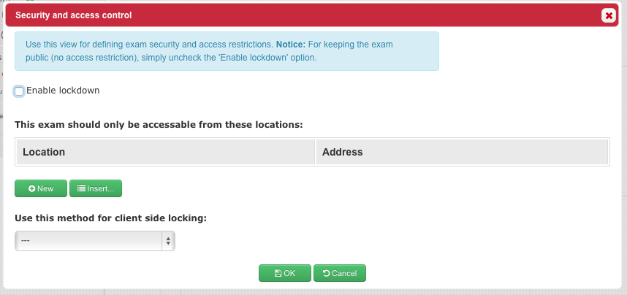

If the “Enable lockdown” checkbox is checked (default), the exam gets locked to the computer it was first opened from to ensure that students can't leave the exam hall and modify their answers later on (during active exam time) from another computer.

For diagnostic or self tests, this is mostly certain an unwanted feature. In this case, make sure to uncheck “Enable lockdown”.

The exam can further be restricted to only trusted places (like exam halls) by choosing one or more allowed locations. Students accessing the exam from these locations is automatic granted access.

## *Pre-defined locations*

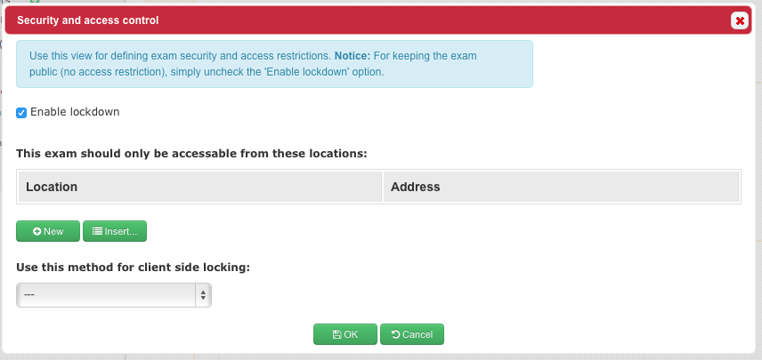

Click on “Insert” to choose a pre-defined location from the dialogue window.

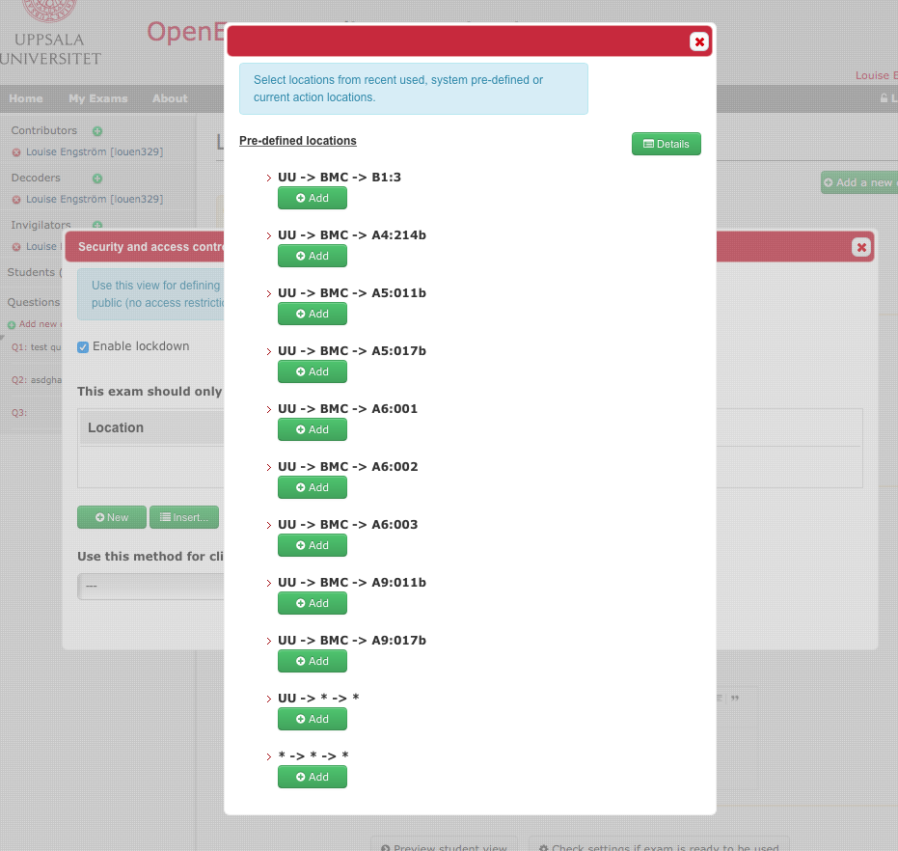

The exam hall with computers that are dedicated to OpenExam is displayed on top (B1:3). Next come other computer rooms at BMC, Uppsala University.

### Wildcard locations

If the students have to connect from an computer at the University choose “UU->*->*”.

If the students are allowed to be elsewhere, for example at home or at an Internet café you choose “*->*->*”.

Students trying to access the exam from a non-approved location will be informed that their access is awaiting approval. Once the invigilator has approved their connection, student will get access to the exam.

## *Custom locations*

If none of the pre-defined location are suitable, then you can define a custom location following these steps:



1. Ensure the Enable lockdown check box is checked.
2. Click on “New”. A line below “Location” and “Address” appear.

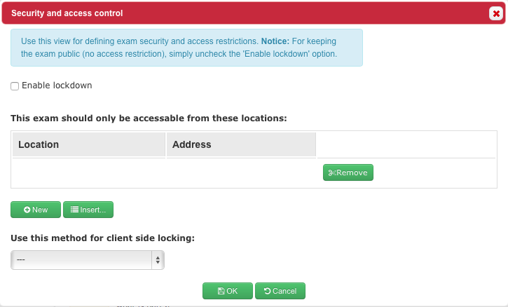

1. Type in a name for the new location on the line under “Location”. This could be any location.
2. In the address field you specify from where your students could access the exam. Possible choices are:  
   * Single IP-address, i.e. “192.168.1.2”
   * Range of IP-addresses: i.e. "192.168.1.34-192.168.2.92"
   * Subnet: i.e. "192.168.1.0/26"
   * DNS name (a regular expression pattern): i.e. "/^.*\.google\..*$/" (this will allow all at Google)

If you at a later stage change your mind about location you can simply go back here and click “Remove” to the right of the address.

Once the location and address(es) are detailed you click “OK” and the lockdown to access is complete.

# During the exam

The invigilators are responsible for some settings if necessary during the exam.

## Adding/removing students during the exam

Log in to OpenExam.

When on the homepage, chose the Invigilator section.

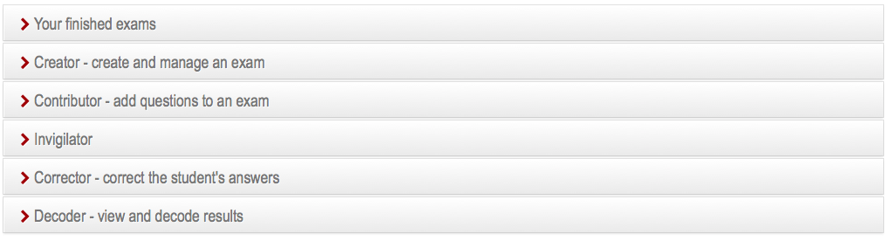

Chose “Manage students” next to the exam that is going.

If you ate having troubles finding the right exam you can check the “sort by” checkbox. Sometimes an active exam was created long ago and therefore is not at the top.

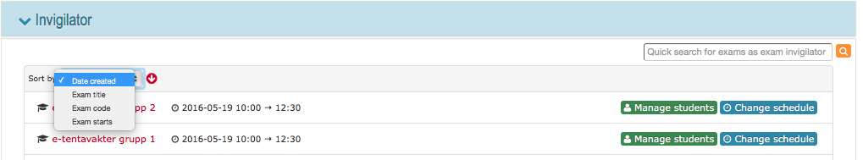

The following window appears. The “Add new student” tab is active (its name is marked red).

If you need to add a student to the exam you do so here by typing their username or personal identity number in the field “identity code”.

Click “Add students”.

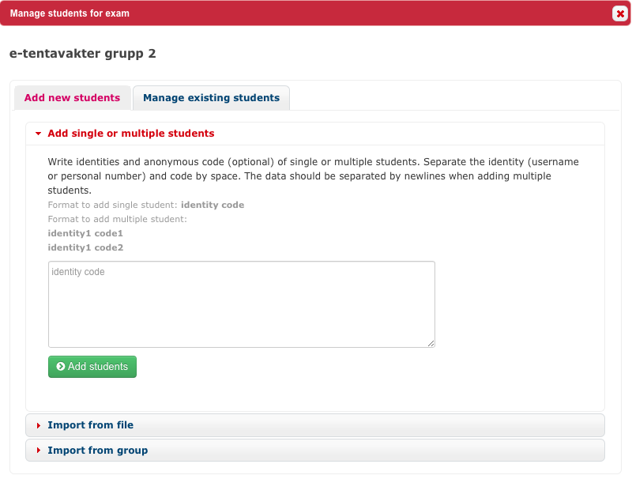

Click on the “Manage existing students” tab.

This is the list of all students added to this exam.

By ticking the box in front of a student’s name you will receive the option to remove that student.

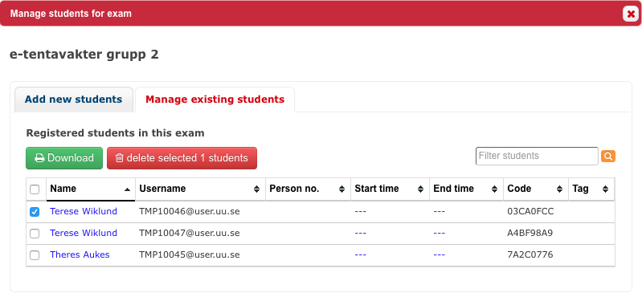

## Changing the exam time during the exam

Under “Start time” and “End time” you can adjust the time that a specific student can sit the exam.

Remember to click OK after editing to set the time.

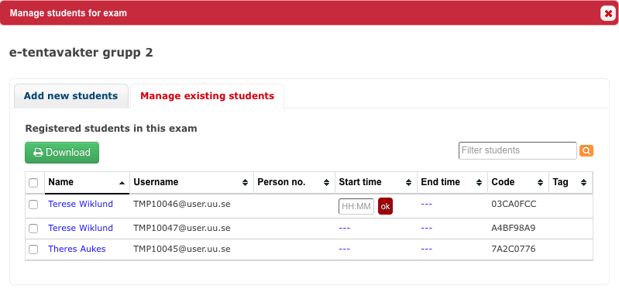

When you have finished editing the student has to refresh his/her webbrowser to activate your changes.

If you need to change the exam time for all students you do that from the Invigilator section. Click on “Change schedule” next to the exam .



# After the exam

When the exam has been finished, assigned correctors can immediately start correcting the questions.

When all questions are corrected the Decoder can decode and the students can be informed of their results.

Below you can see the procedures for each role involved with an exam. Please go to the one relevant to you for information how to move forward.

# Being a Contributor – adding questions

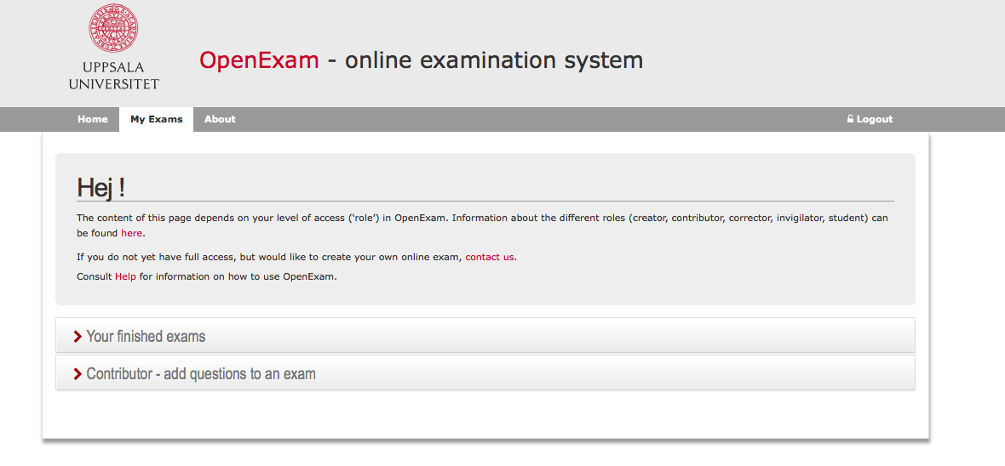

Log in and click on the contributor tab to find the exams you have been added as contributor to. Its possible to add, edit or remove questions until the exam has been published.

If the exam has been closed for further contribution (published) you will get the the following notification “No more open to contribute”

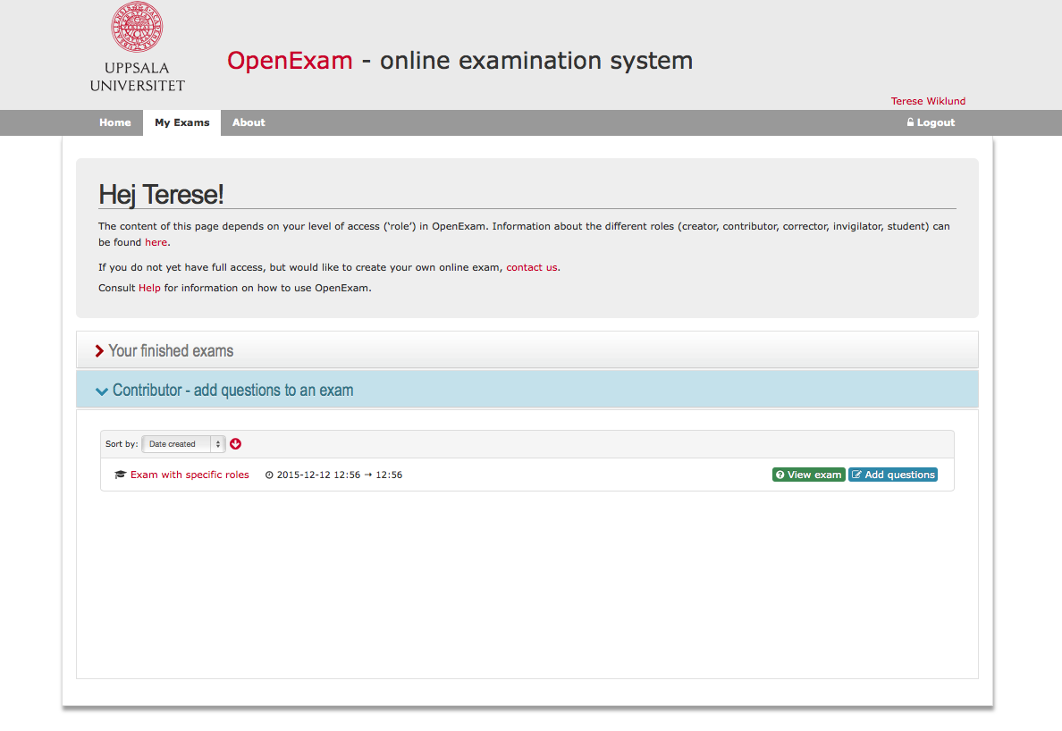

Click on “View exam” and you will see the questions that have already been entered:

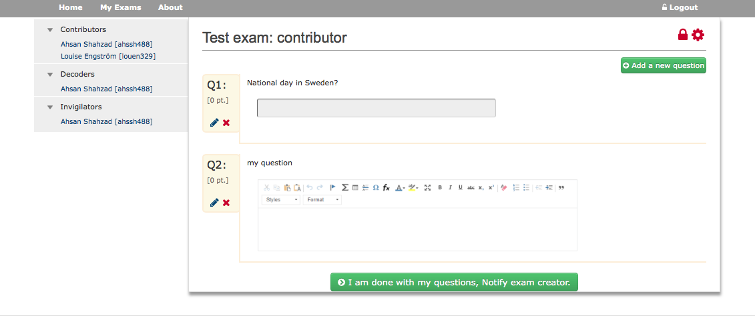

To add a question, follow the instructions in the Adding question section.

When you are done adding questions press the “I am done with my questions, Notify exam creator.” button.

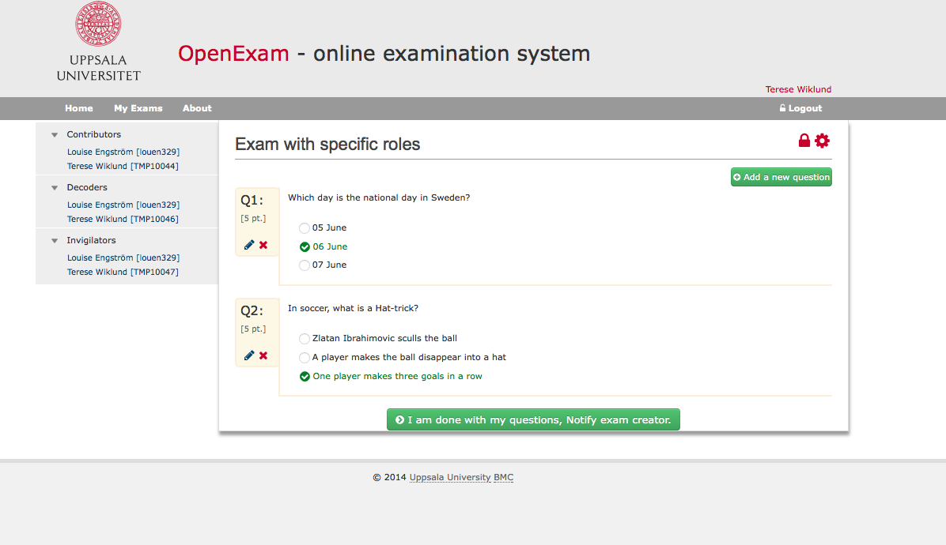

# Being the Corrector – correcting an exam

To correct questions, go to “My Exams”. Chose “Corrector” and click “Answer correction” next to the exam you are correcting:

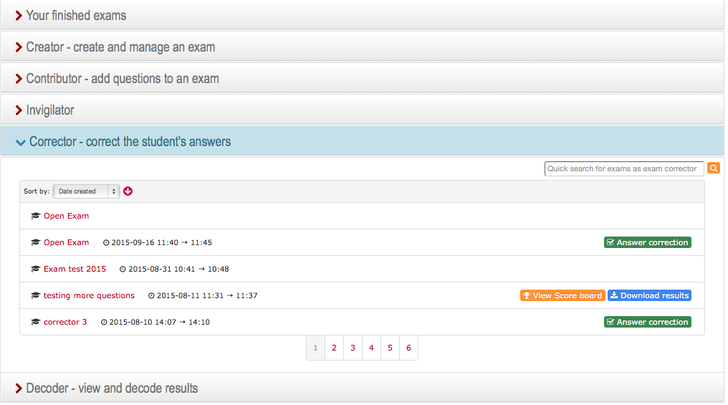

This will open a score board of all students and their answered questions. Note that the students are anonymous and that you can only see the questions you have been assigned to correct.

Uncorrected or partial corrected answers are marked green.

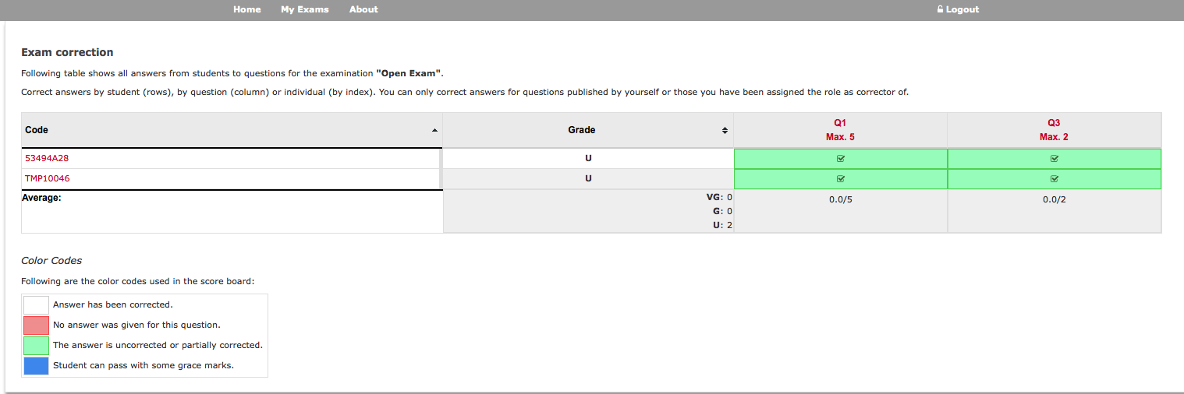

You may choose to:

* Correct all answers by one student (click row link)
* All students answers for one question (by column link).
* By clicking one particular cell you will see the answer to that question by the student on that question.

Click on the link at the beginning of a row and you will see all the answers by that student:

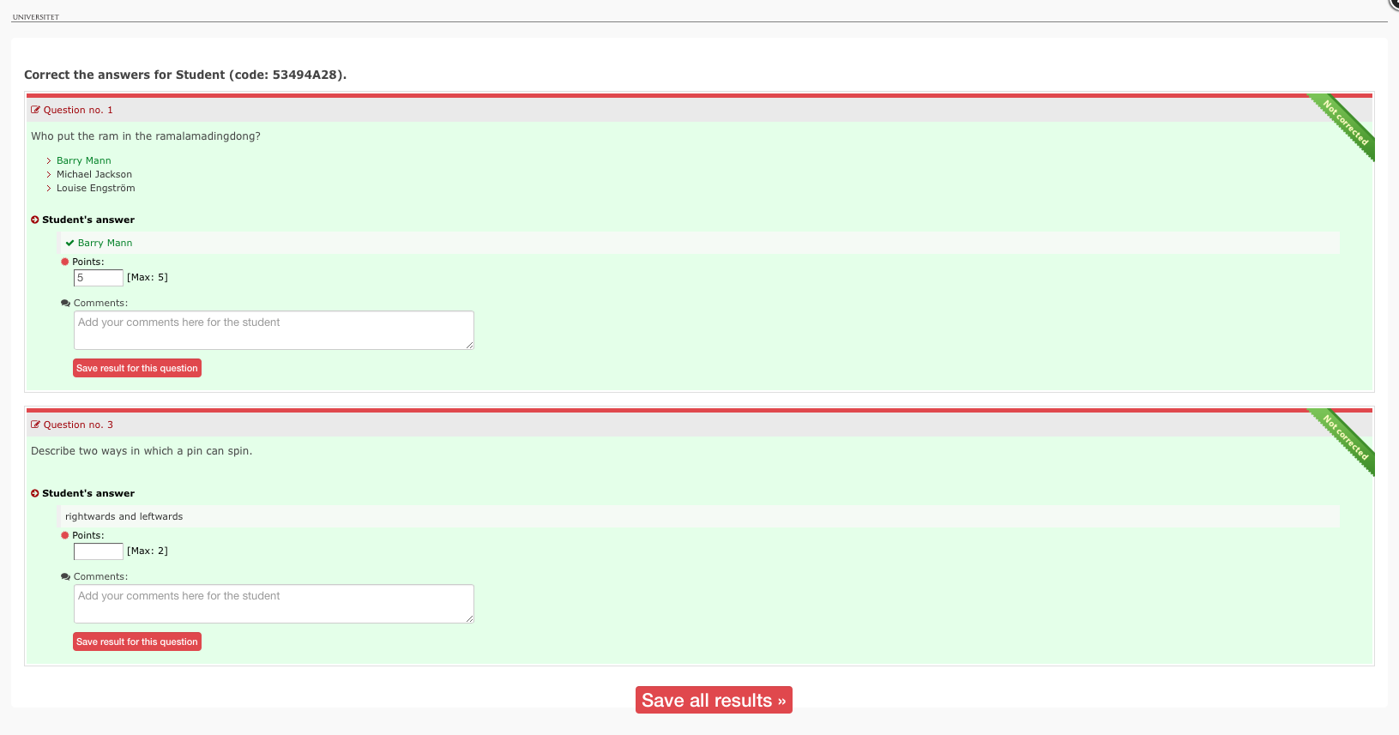

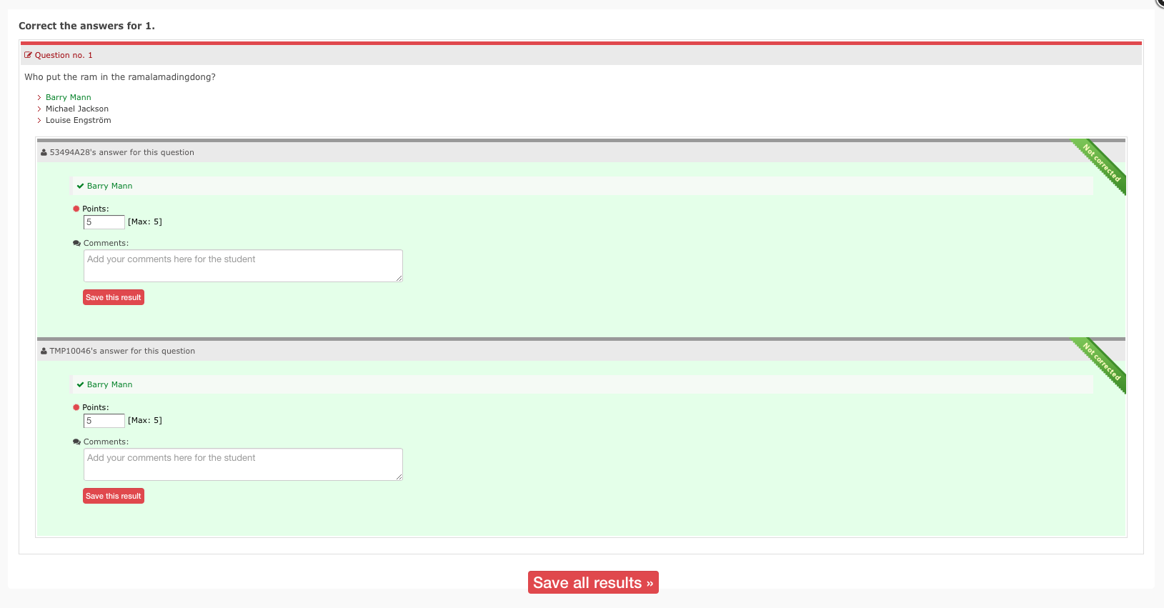

Note, if you are the *creator* of the exam, you will see all questions, even those you are not going to correct yourself. They will however differ by having a lighter colour and no field for you to type a comment in.

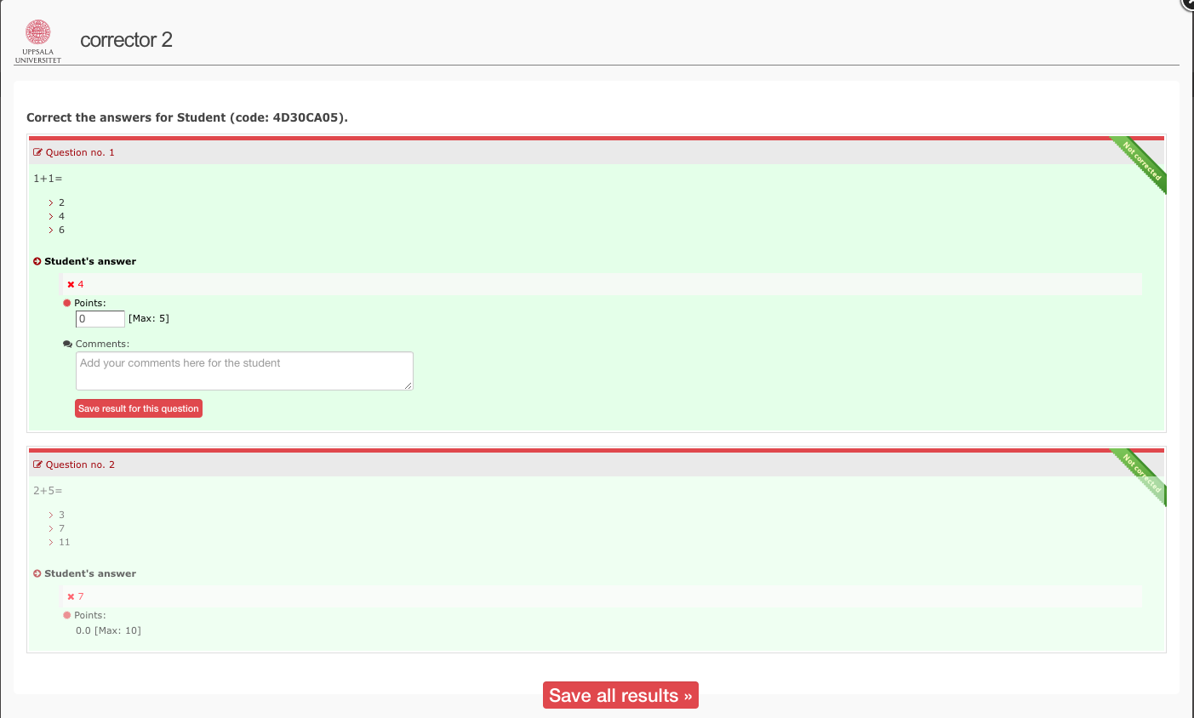

When you have inserted correct scores to the answers and given comments where necessary you can click on “Save all results”. You also have the option to save results individually for each question, by pressing the “Save results for this question” button beneath each question.

The background colour of the corrected questions will turn to white once all answer parts have been assigned a score.

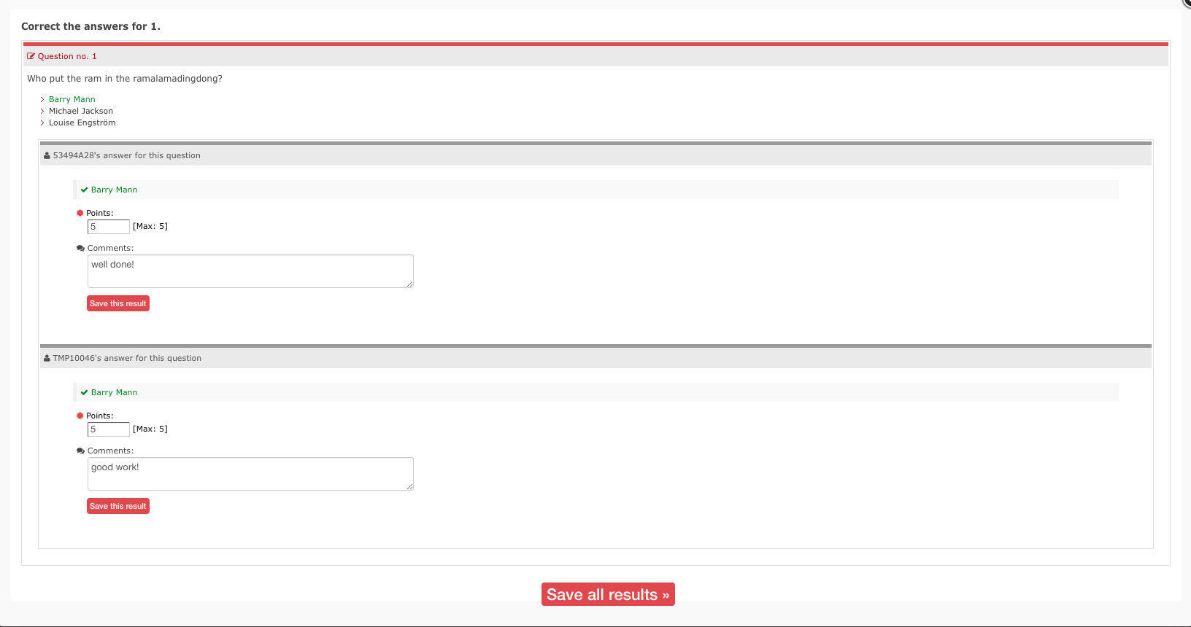

**Note:**

Remember that same exam might have multiple editions, this could be the case when some students are not going to answer the same questions. Make sure to check under the “Corrector” tab to confirm all exams are corrected.

# Being the Decoder – decoding an exam

When all answers on an exam has been corrected, its possible for the decoder to decode the exam, thus reveal the students real identities required for reporting results.

Go to “My exams”. Chose “Decoder” – here you find all exams you are decoder to.

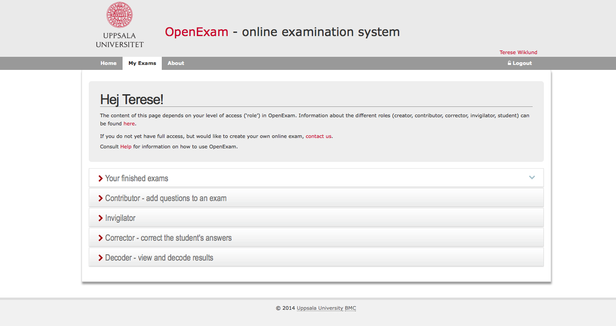

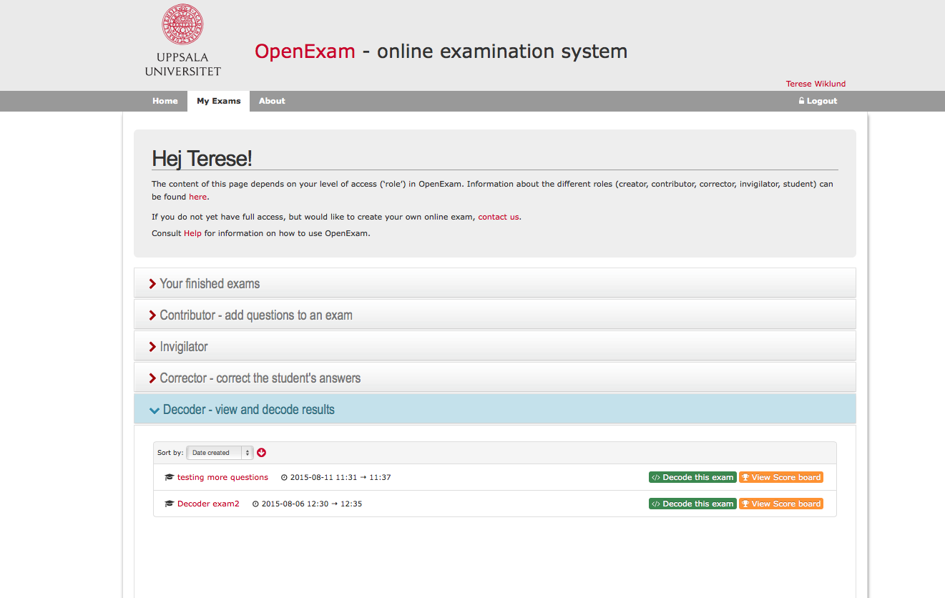

If you click “View Score board”, the orange button to the right, you can see all scores, average etc.

Click on “Decode this exam”, the green button.

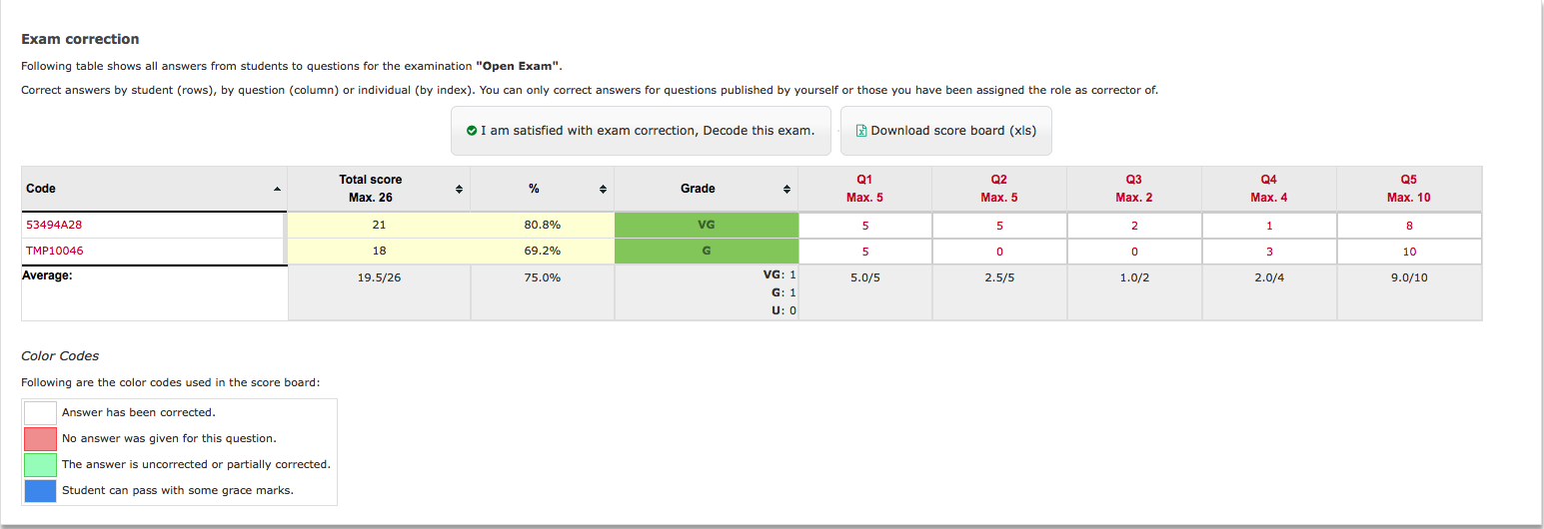

The decoder will see that all questions have been corrected since they are no longer highlighted (if a question has not been corrected it will be highlighted in green).

Click “I am satisfied with exam correction, Decode this exam”.

A pop-up window appears informing you that once an exam is decoded you can no longer change the students’ scores, click OK.

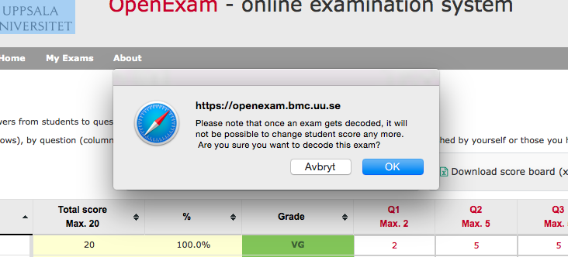

In the window you see the final scores, the statistics and results.

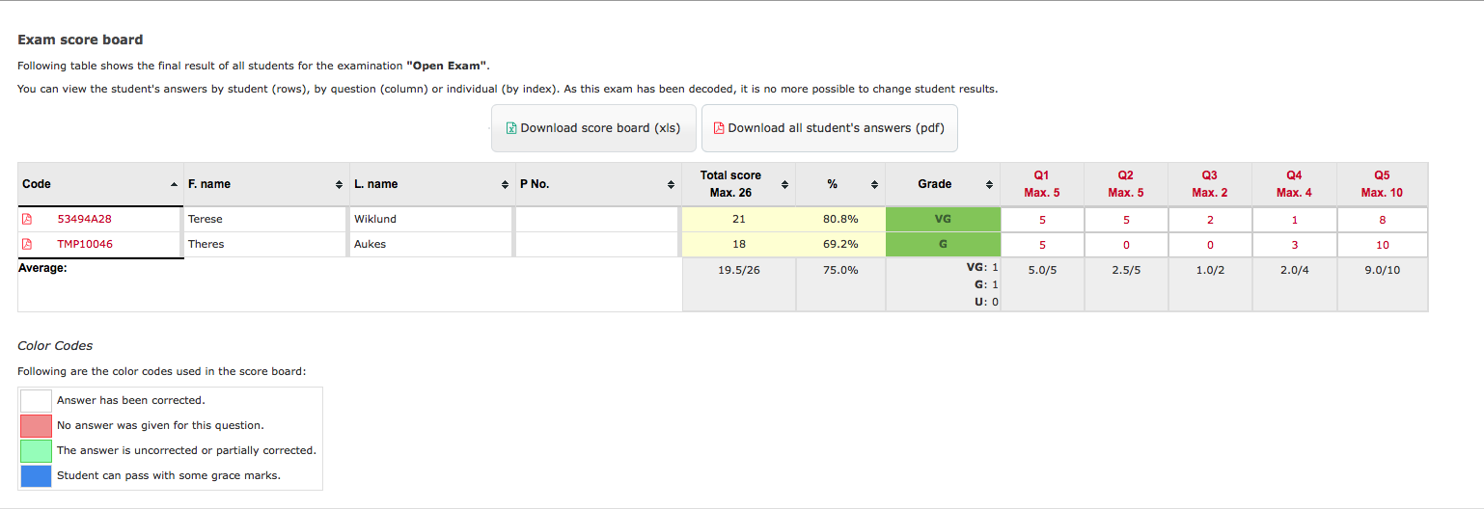

**1**

**2**

You can either download the scoreboard as an excel sheet for filing (No 1 in above picture).

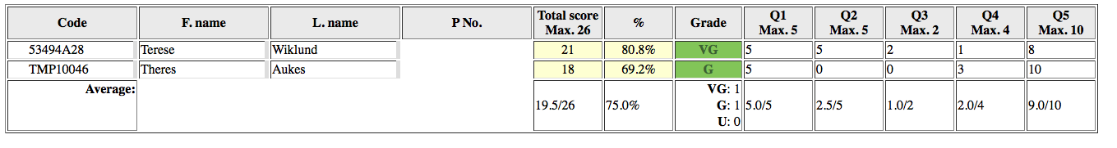

Or you can download all students’ entire exams (questions and answers, see below) in a folder containing separate PDFs (No 2 in the previous picture).

# Student results

Once decoded, the exam result has to be reported back to students. You can choose to either download result files and distribute them by yourself, or tell the students that their result can be downloaded by themselves by logging in online.

## *Example*

This is an example of the PDF document downloadable by the students. The content might look a bit different depending on actual used exam settings.

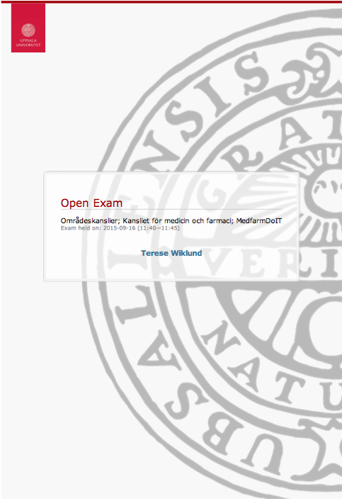

Student Name

If you type any information for the students when you set up the exam it will be written here too.

